**HCMC UNIVERSITY OF TECHNOLOGY AND EDUCATION  
FACULTY FOR INTERNATIONAL EDUCATION**------------------------------



**FINAL REPORT**

**PROJECT ON SOFTWARE ENGINEERING**

**BUILDING A SOCIAL NETWORK SYSTEM**

**INSTRUCTOR**: Nguyen Tran Thi Van, MSc.

**Group: 04**

**Students:**

21110759 Ho Thanh Duy

21110806 Vu Tien Trinh

**Ho Chi Minh City, Dec 2024**

**HCMC UNIVERSITY OF TECHNOLOGY AND EDUCATION  
FACULTY FOR INTERNATIONAL EDUCATION**------------------------------



**FINAL REPORT**

**PROJECT ON SOFTWARE ENGINEERING**

**BUILDING A SOCIAL NETWORK SYSTEM**

**INSTRUCTOR**: Nguyen Tran Thi Van, MSc.

**Group: 04**

**Students:**

21110759 Ho Thanh Duy

21110806 Vu Tien Trinh

**Ho Chi Minh City, Dec 2024**

# **OBJECTIVES FOR PROJECT ON SOFTWARE ENGINEERING**

Full name: Hồ Thanh Duy ….…………………………………….……ID: 21110759

Full name: Vũ Tiến Trình………………………………………….……ID: 21110806

**Major**: Software Engineering

**Project** : Building a social network system

**Contents:**

*Theory:*

* Learn about RESTful API with SpringBoot Framework
* Learn about building website with ReactJs Framework
* Learn about Spring Security (JWT, Oauth)
* Learn about Docker to deploy production
* Learn about Websocket protocol

*Practice:* Build a social network system with base features:

* Profile Management: Update personal info, manage profile pictures, and view profiles.
* Post Management: Create, edit, delete posts; like, comment, and share content.
* Authentication: Register, log in (JWT), with Oauth and password recovery.
* Relationships: Send friend requests, follow/unfollow, and manage connections.
* Real-Time messaging: WebSocket messaging with basic online chatting only sends text.
* File Management: Upload and manage media in posts and profiles.

**Time:** 15 weeks (from 19/08/2024 to 30/11/2024)

 Sign of student: ……………………………………………………………

 Sign of student: ……………………………………………………………

*TP.HCM, day…. Month…. Year …*

  HEAD OF DEPARTMENT     INSTRUCTOR

       (*write, sign full name*) (*write, sign full name*)

**SOCIALIST REPUBLIC OF VIETNAM**

**Independence – Freedom – Happiness**

**------------------------------------**

# **INSTRUCTOR’S EVALUATION SHEET**

**Student Name**: Ho Thanh Duy **Student ID:** 21110759

**Student Name**: Vu Tien Trinh **Student ID:** 21110806

**Project title:** Building a social network system.

**Instructor:** Nguyen Tran Thi Van **, Msc**

**EVALUATION**

**1.** Content of the project:

............................................................................................................................................

............................................................................................................................................

**2.** Strengths:

............................................................................................................................................

............................................................................................................................................

**3.** Weaknesses:

............................................................................................................................................

............................................................................................................................................

**4.** Approval for oral defense? (Approved or denied)

............................................................................................................................................

**5.** Overall evaluation: (Excellent, Good, Fair, Poor)

............................................................................................................................................

**6.** Mark: ………. (in words: .........................................................................................)

Ho Chi Minh City, December 2024

**INSTRUCTOR**

*(Sign with full name)*

**SOCIALIST REPUBLIC OF VIETNAM**

**Independence – Freedom – Happiness**

**------------------------------------**

# **REVIEWER’S EVALUATION SHEET**

**Student Name**: Ho Thanh Duy **Student ID:** 21110759

**Student Name**: Vu Tien Trinh **Student ID:** 21110806

**Project title:** Building a social network system.

**Reviewer:** Mai Anh Tho, **PhD**

**EVALUATION**

**1.** Content of the project:

............................................................................................................................................

............................................................................................................................................

**2.** Strengths:

............................................................................................................................................

............................................................................................................................................

**3.** Weaknesses:

............................................................................................................................................

............................................................................................................................................

**4.** Approval for oral defense? (Approved or denied)

............................................................................................................................................

**5.** Overall evaluation: (Excellent, Good, Fair, Poor)

............................................................................................................................................

**6.** Mark: ………. (in words: .........................................................................................)

Ho Chi Minh City, December 2024

**REVIEWER**

*(Sign with full name)*

# **ACKNOWLEDGEMENT**

First and foremost, I would like to express our heartfelt gratitude to Mr. Nguyễn Trần Thi Văn for his unwavering support and guidance throughout the process of researching and implementing this topic. I'd want to express our gratitude to the teacher for his passionate instruction and guidance in selecting themes, techniques, and rectifying flaws in the implementation process.

I'd also want to express our gratitude to the professors at Ho Chi Minh City's University of Technology and Education, particularly the Faculty Lecturers, who energetically taught and shared a wealth of information and expertise with us during our schooling. To assist me in effectively completing the topic.

However, faults made during the implementation of the topic may be overlooked by teachers. I eagerly await instructor feedback so that I may get more experience and increase my expertise in order to better serve the learning and working process in the future.

|  |  |
| --- | --- |
|  | *Thank you sincerely!*  Hồ Thanh Duy  Vũ Tiến Trình |

**TABLE OF CONTENTS**

**OBJECTIVES FOR PROJECT ON SOFTWARE ENGINEERING** i

**INSTRUCTOR’S EVALUATION SHEET** ii

**REVIEWER’S EVALUATION SHEET** iii

**ACKNOWLEDGEMENT** iv

**TABLE OF CONTENTS** v

**LIST OF FIGURES** xi

**LIST OF TABLES** xiii

**CHAPTER 1. INTRODUCTION** 1

1**. Reasons for choosing the topic** 1

**2. Purpose of the topic** 1

**3. Research subjects and scope** 1

**4. Expected results** 1

**5. Link Github Source code and Website** 2

**CHAPTER 2. THEORETICAL FOUNDATIONS** 3

**2.1. NodeJS** 3

**2.1.1. General NodeJS** 3

**2.1.2. Principles of operation** 3

**2.1.3. Advantages** 4

**2.1.4. Disadvantages** 4

**2.2. ReactJS** 5

**2.2.1. General ReactJS** 5

**2.2.2. Core concept of React** 5

**2.3. PostgresSQL** 7

**2.3.1. General PostgresSQL** 7

**2.3.2. Core principles of Postgres** 7

**2.3.3. Advantages** 7

**2.3.4. Disadvantages** 8

**2.4. Spring Boot Framework** 8

**2.4.1. General Spring boot** 8

**2.4.2. Advantages** 9

**2.4.3. Disadvantages** 9

**2.5. WebSocket** 9

**2.5.1. General Websocket** 9

**2.5.2. Advantages over traditional HTTP** 10

**2.5.3. Disadvantages of WebSocket** 10

**2.6. Library** 10

**2.6.1. Material UI** 10

2.6.2. Axios 11

**2.6.3. Redux** 12

**2.6.4. React router DOM** 13

**CHAPTER 3. REQUIREMENTS CAPTURING AND MODELING** 14

**3.1. Current status survey** 14

**3.1.1. FACEBOOK** 15

**3.1.2. REDDIT** 16

**3.1.3. LINKEDIN** 17

**3.2. Requirements capturing** 18

**3.2.1. List of actions** 18

**3.2.2. Business functional** 20

**3.2.3. System functional** 25

**3.2.4. Non-functional** 26

**3.3. Requirements modeling** 27

**3.3.1. Use case diagrams** 27

**3.3.1.1. User management use case diagram** 27

**3.3.1.2. Media management use case diagram** 28

**3.3.1.3. Post management use case diagram** 29

**3.3.1.4. Friend management use case diagram** 30

**3.3.2. Use case specifications** 30

**3.3.2.1. Use case Register (UC-1)** 30

**3.3.2.2. Use case Login (UC-2)** 31

**3.3.2.3. Use case Change password (UC-3)** 31

**3.3.2.4. Use case Log out (UC-4)** 32

**3.3.2.5. Use case Change profile’s user (UC-5)** 32

**3.3.2.6. Use case Create/Edit/Delete Post (UC-6)** 33

**3.3.2.7. Use case Comment Post (UC-7)** 35

**3.3.2.8. Use case Reaction Post (UC-8)** 35

**3.3.2.9. Use case In-Active account user (UC-9)** 36

**3.3.2.10. Use case Delete account user (UC-10)** 36

**3.3.2.11. Use case Send Message (Chatting) (UC-11)** 37

**3.3.2.12. Use case Follow/Unfollow user (UC-12)** 37

**3.3.2.13. Use case Save Post Items (UC-13)** 38

**3.3.2.14. Use case Change folder for post (UC-14)** 39

**3.3.2.15. Use case Create folder for post (UC-15)** 39

**CHAPTER 4. SYSTEM DESIGN** 41

**4.1. Sequence Diagrams** 41

**4.1.1. Login** 41

**4.1.2. Register** 42

**4.1.3. Create New Profile** 43

**4.1.4. Change Profile’s Information** 44

**4.1.5. Change Password** 45

**4.1.6. Follow User** 46

**4.1.7. Create New Post** 47

**4.1.8. Edit Post** 48

**4.1.9. Reaction** 49

**4.1.10. Comment** 50

**4.1.11. Delete Existed Post** 51

**4.1.12. Add Post To Folder** 52

**4.1.13. Create Folder** 53

**4.1.14. In-active Account** 54

**4.1.15. Delete Account** 55

**4.1.16. Chatting** 56

**4.2. Database design** 57

**4.2.1. Class Diagram** 57

**4.2.2. Entity-Relational Database** 58

4.2.3. Database Description 58

4.2.3.1. User Entity 58

**4.2.3.2. Profile Entity** 59

**4.2.3.3. Address Entity** 60

**4.2.3.4. Role Entity** 60

**4.2.3.5. Post Entity** 60

**4.2.3.5. Content Entity** 61

**4.2.3.6. Reaction Entity** 61

**4.2.3.7. Comment Entity** 62

**4.2.3.8. Image Entity** 62

**4.2.3.9. Follow Entity** 63

**4.2.3.10. Friend Entity** 63

**4.2.3.11. FriendRequest Entity** 64

**4.2.3.12. MediaResources Entity** 64

**4.2.3.13. Notification Entity** 65

**4.2.3.14. PostFolder Entity** 66

**4.2.3.15. ChatMessage Entity** 66

**4.2.3.16. Thread Entity** 67

**4.3. User Interface Design** 67

**4.3.1. Admin Interface** 69

**4.3.1.1. Main Admin Screen (SCU14)** 69

**4.3.2. User Interface** 72

**4.3.2.1. Register screen (SCU01)** 72

**4.3.2.2. Login Screen (SCU02)** 74

**4.3.2.4. Main screen (SCU04)** 75

**4.3.2.6. Feed screen (SCU06)** 76

**4.3.2.7. Saved Items screen (SCU07)** 77

**4.3.2.8. Resource screen (SCU08)** 78

**4.3.2.9. Chat screen (SCU09)** 79

**4.3.2.10. Main friend Management Screen (SCU10)** 80

**4.3.2.11. All Friend Screen (SCU11)** 81

**4.3.2.12. Recommend Friend screen (SCU12)** 82

**4.3.2.13. Follower Screen (SCU13)** 83

**CHAPTER 5. IMPLEMENTATION AND TESTING** 84

**5.1. Implementation** 84

**5.1.1. Application Implementation** 84

**5.1.1.1. Back-End Implement** 84

**5.1.1.2. Front-End Implement** 86

**5.1.2. Tools** 87

**5.1.3. TechStack** 88

**5.2. Testing** 88

**5.2.1. Test case** 89

**5.2.2. Result of Test case** 89

**5.2.2.1. Result of test case Login Function** 89

**5.2.2.2. Result of test case Add Post to folder Function** 91

**5.2.2.3. Result of test case Send friend request** 92

**CHAPTER 6. CONCLUSION** 93

**6.1. Achievements** 93

**6.1.1. Knowledge** 93

**6.1.2. Skills** 93

**6.1.3. Product** 94

**6.2. Pros and Cons** 94

**6.2.1. Pros** 94

**6.2.2. Cons** 94

**6.3. Future work** 95

**REFERENCES** 96

**LIST OF FIGURES**

Figure 2‑1. Virtual DOM (Document Object Model) 6

Figure 2‑2. One-way data bidding model in ReactJS project 6

Figure 2‑3. Java Spring boot Framework Logo 8

Figure 2‑4. Installation Material UI with NPM 11

Figure 2‑5. Installation Material UI with Yarn 11

Figure 2‑6. Installation Axios with NPM 11

Figure 2‑7. Installation React router DOM with NPM 13

Figure 3‑1. Survey Faccebook - Social Media Application 15

Figure 3‑2. Survey Reddit - Social Media Application 16

Figure 3‑3. Survey Linkedin - Social Media Application 17

Figure 3‑4. User management use case diagram 27

Figure 3‑5. Media management use case diagram 28

Figure 3‑6. Post management use case diagram 29

Figure 3‑7. Friend management use case diagram 30

Figure 4‑1. Login Sequence Diagram 41

Figure 4‑2. Register Sequence Diagram 42

Figure 4‑3. Create New Profile Sequence Diagram 43

Figure 4‑4. Change Profile Information Sequence Diagram 44

Figure 4‑5. Change Password Sequence Diagram 45

Figure 4‑6. Follow User Sequence Diagram 46

Figure 4‑7. Create New Post Sequence Diagram 47

Figure 4‑8. Edit Post Sequence Diagram 48

Figure 4‑9. Reaction Sequence Diagram 49

Figure 4‑10. Comment Sequence Diagram 50

Figure 4‑11. Delete Existed Post Sequence Diagram 51

Figure 4‑12. Add Post To Folder Sequence Diagram 52

Figure 4‑13. Create Folder Sequence Diagram 53

Figure 4‑14. In-Active Account Sequence Diagram 54

Figure 4‑15. Delete Account Sequence Diagram 55

Figure 4‑16. Chatting Sequence Diagram 56

Figure 4‑17. Class Diagram of Social Media System 57

Figure 4‑18. Entity-Relational Database 58

Figure 4‑19. Dashboard Admin Screen 69

Figure 4‑20. Table of List Active User 70

Figure 4‑21. User Management Page 71

Figure 4‑22. Register screen 72

Figure 4‑23. Register Form - Profile Information Page 73

Figure 4‑24. Login Screen 74

Figure 5‑25. Main Screen 75

Figure 4‑26. Feed Screen 76

Figure 4‑27. Saved Items screen 77

Figure 4‑28. Resource screen 78

Figure 4‑29. Chatting screen 79

Figure 4‑30. Main friend Management Screen 80

Figure 4‑31. Show All Friend Screen 81

Figure 4‑32. Recommend Friend screen 82

Figure 4‑33. Follow Screen 83

Figure 5‑1. Testcase Login with fail username and password 90

Figure 5‑2. Testcase Save Items successfully 91

Figure 5‑3. Testcase Send Friend Request Successfully 92

# **LIST OF TABLES**

Table 3‑1. Advantages and Disadvantages of Facebook Social Media Application 15

Table 3‑2. Advantages and Disadvantages of Reddit Social Media Application 17

Table 3‑3. Advantages and Disadvantages of Linkedin Social Media Application 18

Table 3‑4. List of actions from requirements capturing 19

Table 3‑5. Detail Requirement's Type of Requirements 20

Table 3‑6. Manage Account Functional 20

Table 3‑7. Manage Post Functional 21

Table 3‑8. Media Resources Functional 21

Table 3‑9. Manage Reporting Functional 22

Table 3‑10. Manage Relationship Functional 23

Table 3‑11. Manage Conversation Functional 23

Table 3‑12. Manage Profile Functional 24

Table 3‑13. Notifications Functional 25

Table 3‑14. Feed and Search Functional 25

Table 3‑15. System Functional 26

Table 3‑16. Non-functional 26

Table 3‑17. Use case Register (UC-1) 31

Table 3‑18. Use case Login (UC-2) 31

Table 3‑19. Use case Change password (UC-3) 32

Table 3‑20. Use case Log out (UC-4) 32

Table 3‑21. Use case Change profile’s user (UC-5) 33

Table 3‑22. Use case Create Post (UC-6) 34

Table 3‑23. Use case Edit Post (UC-6) 34

Table 3‑24. Use case Delete Post (UC-6) 35

Table 3‑25. Use case Comment Post (UC-7) 35

Table 3‑26. Use case Reaction Post (UC-8) 36

Table 3‑27. Use case In-Active account user (UC-9) 36

Table 3‑28. Use case Delete account user (UC-10) 37

Table 3‑29. Use case Send Message (Chatting) (UC-11) 37

Table 3‑30. Use case Follow/Unfollow user (UC-12) 38

Table 3‑31. Use case Save Post Items (UC-13) 39

Table 3‑32. Use case Change folder for post (UC-14) 39

Table 3‑33. Use case Create folder for post (UC-15) 40

Table 4‑1. User Entity 59

Table 4‑2. Profile Entity 60

Table 4‑3. Address Entity 60

Table 4‑4. Role Entity 60

Table 4‑5. Post Entity 61

Table 4‑6. Content Entity 61

Table 4‑7. Reaction Entity 62

Table 4‑8. Comment Entity 62

Table 4‑9. Image Entity 63

Table 4‑10. Follow Entity 63

Table 4‑11. Friend Entity 64

Table 4‑12. FriendRequest Entity 64

Table 4‑13. MediaResources Entity 65

Table 4‑14. Notification Entity 66

Table 4‑15. PostFolder Entity 66

Table 4‑16. ChatMessage Entity 67

Table 4‑17. Thread Entity 67

Table 4‑18. List of User Interface Design 69

Table 4‑19. Dashboard Admin Screen 70

Table 4‑20. Table of List Active User 70

Table 4‑21. User Management Page 71

Table 4‑22. Register screen 72

Table 4‑23. Register Form - Profile Information Page 73

Table 4‑24. Login Screen 74

Table 4‑25. Main Screen 76

Table 4‑26. Feed Screen 77

Table 4‑27. Saved Items screen 77

Table 4‑28. Resource screen 78

Table 4‑29. Chatting screen 79

Table 4‑30. Main friend Management Screen 81

Table 4‑31. All Friend Screen 82

Table 4‑32. Recommend Friend screen 82

Table 4‑33. Follow Screen 83

Table 5‑1. List of application need for Social Application 84

Table 5‑2. Back-End env variables 86

Table 5‑3. Front-End env variables 87

Table 5‑4. Tool needed for Social Application 88

Table 5‑5. Technologies Stask of Social Media Application 88

Table 5‑6. Test case to test function (Login, Add to folder, Send friend request) 89

Table 5‑7. Test case Login with wrong username or password 90

Table 5‑8. Test case add post to folder successfully 91

Table 5‑9. Test case Send friend request to other user 92

# **CHAPTER 1. INTRODUCTION**

## 1**. Reasons for choosing the topic**

The development of technology in the 4.0 era today has been expanding with the emergence of social networking applications that have been a trend that brings many utilities to help people connect quickly, anytime, anywhere in the world through the Internet. Social networking applications have had many influences on people's lives such as Facebook, Zalo, Instagram, Reddit and many related applications. However, these social networks have not really targeted a specific research object. This is a topic that the group aims to bring a virtual social environment to users.

## **2. Purpose of the topic**

The purpose of the topic is to target the rapid development of the need to share and find information quickly from specific websites instead of using Google to search for information, which takes a lot of time. With Smartphones, users can completely search for information quickly in the most convenient way.

## **3. Research subjects and scope**

The target audience includes 2 groups of subjects: the group of subjects who have knowledge, experience and experience through some prominent products on the market such as TikTok, Facebook and the remaining group is low-tech users who do not have much experience with advanced social networking applications today.

In which the group of subjects on technology knowledge includes in-depth research on: Open source Java Spring boot, Library ReactJs, MongoDB database, Postgresql and libraries related to the research issue. In which, in-depth research on the topic of real-time with technologies such as WebSocket to send notifications, chat quickly and conveniently for users, specialized technologies such as Json Web Token, ...

## **4. Expected results**

The anticipated outcomes of the project include:

* Gaining a clear understanding of popular forms of online exams and the technologies used to build web platforms, specifically ReactJs, Spring boot and RESTful API.
* Successfully developing a web application that supports test creation and test-taking with a simple and user-friendly interface. Ensure the implementation of essential functionalities for test takers, test creators, and administrators as initially intended.

## **5. Link Github Source code and Website**

Front-End: <https://github.com/SOCIAL-NETWORK-2425/social-network-frontend>

Back-End: <https://github.com/SOCIAL-NETWORK-2425/social-network-backend>

# **CHAPTER 2. THEORETICAL FOUNDATIONS**

## **2.1. NodeJS**

### **2.1.1. General NodeJS**

**Node.js** is an open-source and cross-platform JavaScript runtime environment. It is a popular tool for almost any kind of project!

**Node.js** runs the V8 JavaScript engine, the core of Google Chrome, outside of the browser. This allows Node.js to be very performant.

A Node.js app runs in a single process, without creating a new thread for every request. Node.js provides a set of asynchronous I/O primitives in its standard library that prevent JavaScript code from blocking and generally, libraries in Node.js are written using non-blocking paradigms, making blocking behavior the exception rather than the norm.

### **2.1.2. Principles of operation**

*Event-Driven Architecture*

Node.js operates on an event-driven architecture, centered around an event loop. This core mechanism continuously monitors the call stack and handles tasks asynchronously, ensuring efficient resource utilization. Key components of the event loop include:

* Timers: Execute callbacks after a specified delay (e.g., setTimeout).
* I/O Callbacks: Handle the completion of non-blocking I/O operations.
* Polling: Retrieves new I/O events.
* Check: Executes setImmediate callbacks.

*Single-Threaded with Non-blocking I/O*

Despite its single-threaded nature, Node.js excels in handling concurrent connections. It achieves this by offloading I/O and intensive operations to worker threads (via the libuv thread pool) or external systems. This non-blocking approach prevents the main thread from being blocked, allowing it to efficiently process multiple requests simultaneously.

*Module and Package*

Node.js leverages a modular architecture, providing both built-in and third-party modules.

* **Built-in Modules:** Essential modules like http (for creating servers), fs (file system operations), and path (handling file paths) are included by default.
* **NPM (Node Package Manager):** The world's largest software registry, offering millions of packages for various functionalities. Developers can easily install, manage, and share these packages to extend the capabilities of their Node.js applications.

### **2.1.3. Advantages**

* **Speed**: Node.js is fast, leveraging an event loop and non-blocking I/O for handling multiple concurrent requests efficiently.
* **Productivity**: Node.js is ideal for real-time, single-threaded applications like chat and video streaming.
* **Error Handling**: Built-in mechanisms simplify catching and managing runtime errors using event-based error objects.
* **Cost-Effectiveness**: Node.js reduces IT costs through minimal hardware requirements and low maintenance expenses.
* **Faster Development**: Allows building high-performance apps quickly, ideal for microservices and rapid product launches.
* **Performance in Slow Networks**: Its single-threaded, non-blocking I/O model ensures fast response in environments with slow connections.
* **Scalability**: Highly scalable, it adapts quickly to changing data needs, and cloud providers enhance performance.

### **2.1.4. Disadvantages**

* **Asynchronous Programming Model:** Asynchronous programming allows program elements to run independently in parallel or sequentially when dependent.
* **Unstable API:** An unstable API may change frequently, causing issues for developers who rely on consistency for their software.
* **Dealing with Relational Databases:** Relational databases are widely used but can be more complex to work with compared to non-relational ones, even with Node.js tools like MySQL modules or ORMs.
* **Memory Leaks:** Poorly coded Node.js applications can lead to memory leaks, but tools like heapdump and careful coding can prevent this.

## **2.2. ReactJS**

### **2.2.1. General ReactJS**

**React** is a versatile JavaScript library designed to construct user interfaces (UIs) for web applications. It empowers developers to create dynamic and interactive user experiences by breaking down complex UIs into reusable components.

### **2.2.2. Core concept of React**

**Components:** These are self-contained building blocks that encapsulate UI logic and data. They can be either functional or class-based, offering flexibility in their implementation.

**JSX:** This syntax extension for JavaScript allows developers to write HTML-like structures within JavaScript code, making it easier to define the structure of UI components.

**Virtual DOM:** React employs a virtual DOM, a lightweight representation of the actual DOM. This optimization technique minimizes the number of DOM manipulations required, resulting in significant performance improvements.

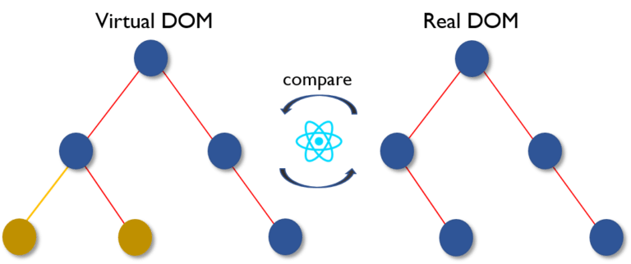

Figure 2‑1. Virtual DOM (Document Object Model)

**One-way data binding:** Props are used to convey data from parent to child. It's straightforward to control and remedy problems using a simple data flow. With the characteristics listed above, ReactJS is used to create huge apps with data that changes over time. When the interface changes, the majority of the data changes as well.

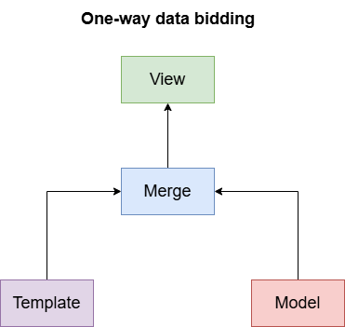

Figure 2‑2. One-way data bidding model in ReactJS project

## **2.3. PostgresSQL**

### **2.3.1. General PostgresSQL**

**PostgreSQL** is a powerful, open source object-relational database system that uses and extends the SQL language combined with many features that safely store and scale the most complicated data workloads. The origins of PostgreSQL date back to 1986 as part of the POSTGRES project at the University of California at Berkeley and has more than 35 years of active development on the core platform.

**PostgreSQL** has earned a strong reputation for its proven architecture, reliability, data integrity, robust feature set, extensibility, and the dedication of the open source community behind the software to consistently deliver performant and innovative solutions. PostgreSQL runs on all major operating systems, has been ACID-compliant since 2001, and has powerful add-ons such as the popular PostGIS geospatial database extender. It is no surprise that PostgreSQL has become the open source relational database of choice for many people and organizations.

### **2.3.2. Core principles of Postgres**

This architecture enables a PostgreSQL system to cater to multiple clients, connecting either locally or through network. When the master process receives a client connection, it forks (ie, the creation of an independent process that will consume CPU and RAM and executes on its own) a new process dedicated to that specific connection. If multiple clients are connecting, each client gets a forked process.

Since each forked process consumes CPU cores and RAM, the number of clients connecting to the server simultaneously are limited by the available cores and RAM. Any new client requests after the server resources are exhausted will be declined. In such cases, clients have to retry.

### **2.3.3. Advantages**

* PostgreSQL is an open-source database that provides affordable solutions without a license charge.
* PostgreSQL maintains data integrity by enforcing constraints, verifying data types, and enabling referential integrity through foreign vital regulations.
* PostgreSQL maintains data integrity by enforcing constraints, verifying data types, and enabling referential integrity through foreign vital regulations.
* PostgreSQL is built to manage demanding workloads and large-scale applications. Sharding facilitates horizontal scalability and offers performance-enhancing tools like query planning, caching, and parallel query execution.

### **2.3.4. Disadvantages**

* Postgres is not owned by one organization. So, it has had trouble getting its name out there despite being fully featured and comparable to other DBMS systems
* Changes made for speed improvement requires more work than MySQL as PostgreSQL focuses on compatibility
* Many open source apps support MySQL, but may not support PostgreSQL
* On performance metrics, it is slower than MySQL.

## **2.4. Spring Boot Framework**

### **2.4.1. General Spring boot**

Spring Boot is an open-source Java-based framework that simplifies the development of standalone, production-grade Spring applications. It provides rapid application development experience by automating configuration and setup tasks, reducing boilerplate code, and offering a wide range of features out of the box.



Figure 2‑3. Java Spring boot Framework Logo

### **2.4.2. Advantages**

* Time-efficient and effortless development of Spring-based apps.
* Autoconfiguration of all components for a production-grade Spring application.
* Prebuilt embedded servers (Tomcat, Jetty, and Undertow), leading to accelerated and more productive app deployment.
* HTTP end-points, letting enter inner app features such as metrics, health status, etc and don’t have XML configuration.
* A vast choice of plugins, facilitating developers’ work with embedded and in-memory databases.
* Easy access to databases and queue services such as MySQL, Oracle, MongoDB, Redis, ActiveMQ, and others.
* Large community and a great variety of tutorials, facilitating the getting-to-know period.

### **2.4.3. Disadvantages**

* Lack of control:
* Due to the opinionated style, Spring Boot creates many unused dependencies that result in large deployment file size.
* The challenging and time-consuming process of converting the legacy or existing Spring project into the Spring Boot apps.
* Not suitable for large-scale projects:  Working seamlessly with microservices, according to many developers, Spring Boot doesn’t fit well for building monolithic applications.

## **2.5. WebSocket**

### **2.5.1. General Websocket**

**WebSocket** is used as a communication protocol that provides full-duplex communication channels over a single, long-lived connection between a client and a server. In this protocol, there are no restrictions like HTTP that for a response you have to make a request first. The server can send the message without getting any request and we use it in the chat feature and send notifications.

### **2.5.2. Advantages over traditional HTTP**

* Persistent connections reduce bandwidth and latency compared to HTTP methods like long polling.
* Supported by major browsers and numerous libraries/frameworks across programming languages.
* Allows custom application-level protocols and extensions (e.g., pub/sub messaging).
* Instantly pushes data, ideal for unpredictable events like alerts.
* Enables simultaneous bidirectional messaging, perfect for multi-user applications like chat rooms.
* Outperforms one-way protocols like Server-Sent Events (SSE).

### **2.5.3. Disadvantages of WebSocket**

* Complex Setup: More effort compared to simpler protocols like HTTP.
* Security Risks: Requires careful handling to avoid vulnerabilities like CSWSH.
* Scalability Issues: Persistent connections increase server resource use.
* Limited Support: Older or specialized browsers may lack full support.
* Overhead for Small Apps: May be excessive for low-frequency communication.
* State Management: Requires explicit handling of persistent sessions.

## **2.6. Library**

### **2.6.1. Material UI**

*Definition*

**Material UI** is an open-source React component library that implements Google's Material Design.

It includes a comprehensive collection of prebuilt components that are ready for use in production right out of the box and features a suite of customization options that make it easy to implement your own custom design system on top of our components.

*Installation*

* Using npm

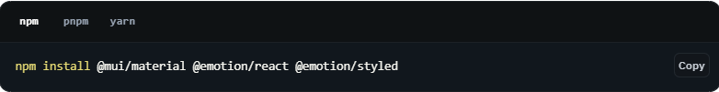

Figure 2‑4. Installation Material UI with NPM

* Using yarn

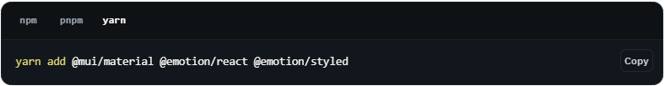

Figure 2‑5. Installation Material UI with Yarn

### 2.6.2. Axios

*Definition*

**Axios** is a promise-based HTTP Client for node.js and the browser. It is isomorphic (= it can run in the browser and nodejs with the same codebase). On the server-side it uses the native node.js http module, while on the client (browser) it uses XMLHttpRequests.

*Installation*

* Using npm

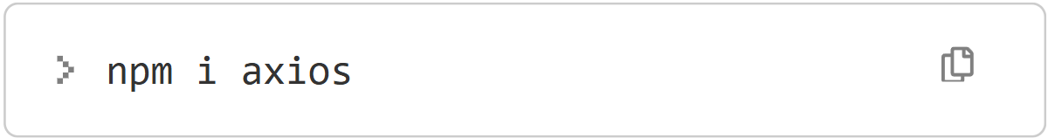

Figure 2‑6. Installation Axios with NPM

### **2.6.3. Redux**

*Definition*

**Redux** is an open source JavaScript library for centralizing and managing application state. It is most commonly used with libraries like React or Angular to build user interfaces. Similar to Facebook's Flux architecture, it was created by Dan Abramov and Andrew Clark**.**

**Redux** is a pattern and library for managing and updating application state, using events called "actions". It serves as a centralized store for state that needs to be used across your entire application, with rules ensuring that the state can only be updated in a predictable fashion.

*Core concept of Redux*



Figure 2‑7. Operation of State Management Redux

Redux has three main components: Actions, Store, and Reducers:

* **Actions**: are events, the method we use to send data from the application to the Redux store, this data can be user interactions with the application, API calls.
* **Reducers**: are functions that take the current state of the application, perform an action and return a response about a new state. States are stored as objects and are defined how they change in response to an action sent to the store.
* **Store**: is the only one in an application that uses Redux to store state, which can be access stored state, change state, and register or unregister listeners via helper methods.

### **2.6.4. React router DOM**

*Definition*

**React Router DOM** is an npm package that enables you to implement dynamic routing in a web app. It allows you to display pages and allow users to navigate them. It is a fully-featured client and server-side routing library for React.

React Router Dom is used to build single-page applications i.e. applications that have many pages or components but the page is never refreshed instead the content is dynamically fetched based on the URL. This process is called Routing and it is made possible with the help of React Router Dom.

*Installation*

* Using npm

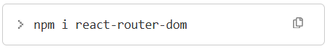

Figure 2‑7. Installation React router DOM with NPM

# **CHAPTER 3. REQUIREMENTS CAPTURING AND MODELING**

## **3.1. Current status survey**

Social media applications have continued to grow and evolve in 2024, reflecting both regional and global shifts in user engagement. The number of social media users has surged to over 5 billion globally, marking an 8% annual growth. This trend illustrates not only increasing accessibility to technology but also a deepening integration of social media into daily life. Platforms like TikTok, Instagram, and YouTube have experienced notable growth in users, with TikTok seeing a dramatic rise in its ad audience, particularly among younger demographics. Instagram has also strengthened its position, attracting a significant portion of the U.S. population through its focus on visual storytelling and brand discovery.

The behavior of users across different platforms highlights evolving interaction patterns, with many using social media for exploring brands, engaging with video content, and connecting through shared interests. Video formats, especially longer ones, continue to dominate engagement metrics, showcasing their role in capturing attention and driving conversations. Meanwhile, regional penetration varies widely, with Europe maintaining some of the highest usage rates, while areas in Africa show opportunities for growth.

An analysis of the current landscape and performance of various social media application:

### **3.1.1. FACEBOOK**

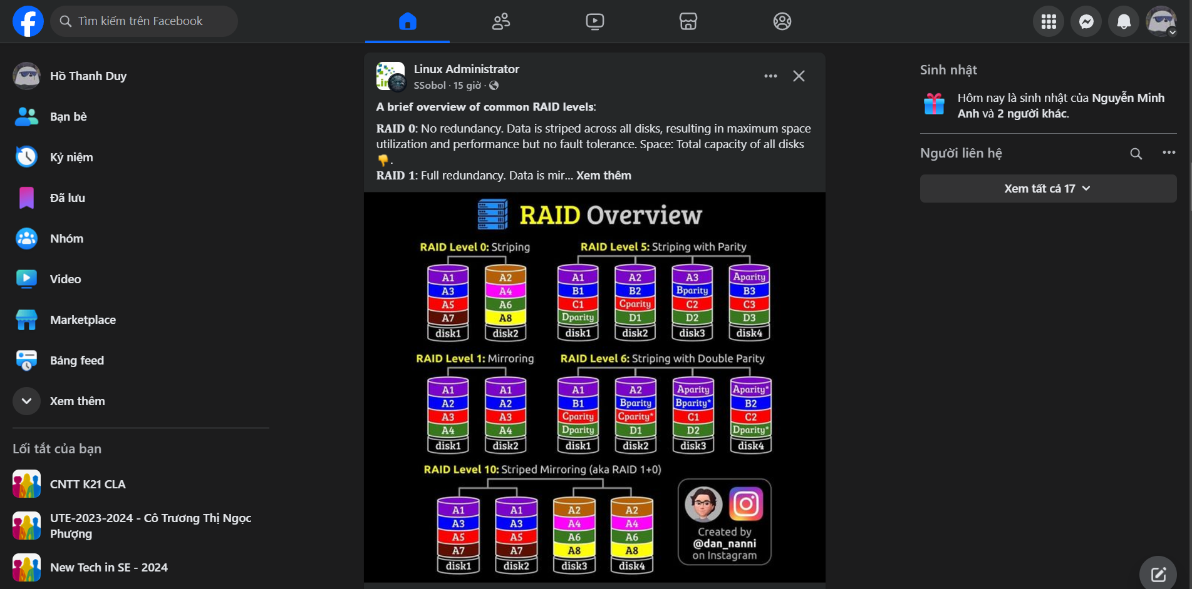

Figure 3‑1. Survey Faccebook - Social Media Application

|  |  |
| --- | --- |
| **Advantages** | - Large user base enables broad social and business networking.  - Offers versatile features like groups, marketplace, and events for diverse purposes.  - Robust advertising platform with advanced targeting options for businesses.  - Easy to use, connecting people across the globe with intuitive tools. |
| **Disadvantages** | - Concerns over privacy and data security due to past breaches.  - Increasing spread of misinformation and unregulated content.  - Declining popularity among younger users, who prefer other platforms.  - Algorithmic feeds can encourage excessive screen time and decrease productivity. |

Table 3‑1. Advantages and Disadvantages of Facebook Social Media Application

### **3.1.2. REDDIT**

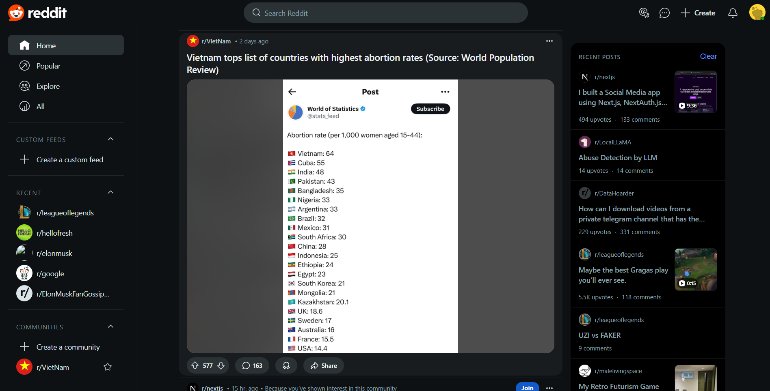

Figure 3‑2. Survey Reddit - Social Media Application

|  |  |
| --- | --- |
| **Advantages** | - Community-driven platform allows for in-depth discussions on niche topics through subreddits.  - Users can remain anonymous, providing privacy and freedom of expression.  - Wide variety of content, from entertainment to educational resources, curated by users.  - Transparent, user-driven moderation fosters a sense of community and inclusiveness. |
| **Disadvantages** | - Decentralized moderation can lead to inconsistency in quality and handling of inappropriate content.  - Some subreddits may foster toxic environments or polarizing debates.  - Interface and culture can be challenging for new users to adapt to.  - Quality of content is inconsistent, as it heavily depends on user contributions. |

Table 3‑2. Advantages and Disadvantages of Reddit Social Media Application

### **3.1.3. LINKEDIN**

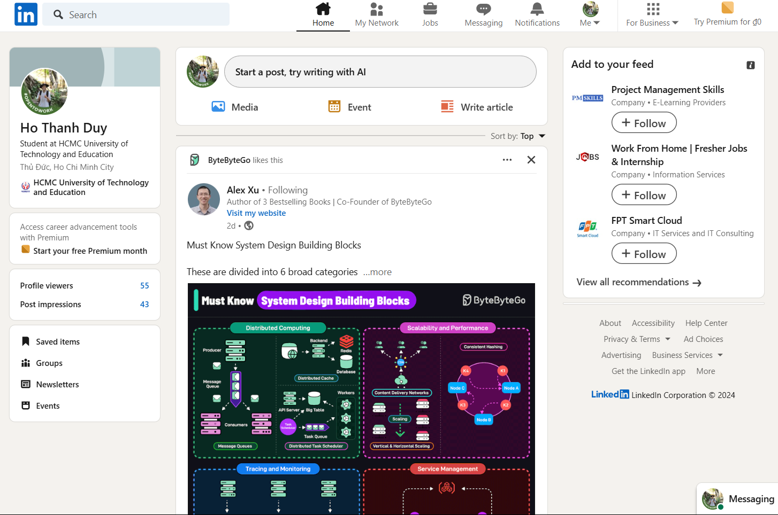

Figure 3‑3. Survey Linkedin - Social Media Application

|  |  |
| --- | --- |
| **Advantages** | - Focused on professional networking, making it ideal for career growth and job hunting.  - Provides a platform to showcase professional skills, achievements, and portfolios.  - Valuable resource for companies to recruit talent and generate leads.  - Analytics tools help users measure their reach and engagement effectively. |
| **Disadvantages** | - Many advanced features, such as InMail and analytics, require costly premium subscriptions.  - Can feel overly formal and lacks casual interaction compared to other platforms.  - High competition on job postings can make it harder for applicants to stand out.  - Users may encounter spam or excessive solicitation from recruiters or salespeople. |

Table 3‑3. Advantages and Disadvantages of Linkedin Social Media Application

## **3.2. Requirements capturing**

### **3.2.1. List of actions**

|  |  |
| --- | --- |
| **Management** | **Action** |
| Account | - Login with authentication |
| Post | - Create post  - Attach files  - Edit post  - Set post’s status  - Tag Friends  - Delete post  - Reaction/ Comment/ Share post |
| Media Resources | - Upload Media  - View/ Download Media |
| Reporting | - View User Activity Reports  - Manage User Accounts  - Monitor Content  - Approve/Reject Posts  - Ban/Unban Users  - View Admin Actions History  - Assign Admin Roles |
| Relationship | - Send Friend Requests  - Manage Friends List |
| Conversation | - Send Messages  - File Sharing in Chat  - Online Status |
| Profile | - View Profile  - Edit Profile Information  - Upload Profile Picture  - Update Contact Information  - View Friends/Followers List  - Set Profile Visibility  - Profile Activity Log  - Deactivate Account |
| Notifications | - Post Notifications  - Message Notifications |
| Feed and search | - View Posts in News Feed  - Filter News Feed Content  - Search Users |

Table 3‑4. List of actions from requirements capturing

|  |  |
| --- | --- |
| **Type** | **Detail Requirement’s Type** |
| Storage | Storing or persisting data in a database or other storage system. |
| Lookup | Fetching data from a predefined set of values or reference data (e.g., drop-downs, lists). |
| Search | Querying data from the system with filters or search criteria. |
| Output | Displaying data, such as reports or data views, to users. |

Table 3‑5. Detail Requirement's Type of Requirements

### **3.2.2. Business functional**

|  |  |  |  |  |  |  |
| --- | --- | --- | --- | --- | --- | --- |
| **Division: Manage Account** | | | | **ID:** | | |
| **No.** | **Function** | **Type** | **Constrains/**  **Formula code** | | **Form code** | **Description** |
| 1 | Login | Search | Only username & password with authentication from system can login | |  | Check authentication user account and login application |

Table 3‑6. Manage Account Functional

|  |  |  |  |  |  |  |
| --- | --- | --- | --- | --- | --- | --- |
| **Division: Manage Post** | | | | **ID:** | | |
| **No.** | **Function** | **Type** | **Constrains/**  **Formula code** | | **Form code** | **Description** |
| 1 | Create post | Storage |  | |  | Users can create posts with text, images, videos, or links. |
| 2 | Attach files | Storage |  | |  | Users can attach files (images, videos, documents) to posts. |
| 3 | Edit post | Storage |  | |  | Users can edit their posts after publishing. |
| 4 | Set post’s status | Storage |  | |  | Adjusting post’s status after publishing |
| 5 | Tag Friends | Output |  | |  | Users can tag friends in posts and photos. |
| 6 | Delete post | Storage |  | |  | Users can delete their own posts. |
| 7 | Reaction/  Comment/  Share post | Output |  | |  | Users can interact with posts through likes, comments, etc. |

Table 3‑7. Manage Post Functional

|  |  |  |  |  |  |  |
| --- | --- | --- | --- | --- | --- | --- |
| **Division: Media Resources** | | | | **ID:** | | |
| **No.** | **Function** | **Type** | **Constrains/**  **Formula code** | | **Form code** | **Description** |
| 1 | Upload Media | Storage |  | |  | Users can upload photos and videos to their profiles. |
| 2 | View/  Download Media | Output |  | |  | Users can view and download uploaded media content. |

Table 3‑8. Media Resources Functional

|  |  |  |  |  |  |  |
| --- | --- | --- | --- | --- | --- | --- |
| **Division: Manage Reporting** | | | | **ID:** | | |
| **No.** | **Function** | **Type** | **Constrains/**  **Formula code** | | **Form code** | **Description** |
| 1 | View User Activity Reports | Output | Admin | |  | Admins can view detailed reports on user activities (posts, messages, interactions). |
| 2 | Manage User Accounts | Output | Admin | |  | Admins can deactivate, delete, or reset user accounts. |
| 3 | Monitor Content | Output | Admin | |  | Admins can monitor posts, comments, and media for violations. |
| 4 | Approve/  Reject Posts | Output | Admin | |  | Admins can approve or reject posts pending moderation. |
| 5 | Ban/Unban Users | Output | Admin | |  | Admins can ban or unban users for violating platform policies. |
| 6 | View Admin Actions History | Output | Admin | |  | Admins can review the history of actions taken by other admins. |
| 7 | Assign Admin Roles | Output | Admin | |  | Admins can assign or remove admin roles to/from other users. |

Table 3‑9. Manage Reporting Functional

|  |  |  |  |  |  |  |
| --- | --- | --- | --- | --- | --- | --- |
| **Division: Manage Relationship** | | | | **ID:** | | |
| **No.** | **Function** | **Type** | **Constrains/**  **Formula code** | | **Form code** | **Description** |
| 1 | Send Friend Requests | Storage |  | |  | Users can send requests to other users to become friends. |
| 2 | Manage Friends List | Lookup |  | |  | Users can organize, view, or remove friends from their list. |

Table 3‑10. Manage Relationship Functional

|  |  |  |  |  |  |  |
| --- | --- | --- | --- | --- | --- | --- |
| **Division: Manage Conversation** | | | | **ID:** | | |
| **No.** | **Function** | **Type** | **Constrains/**  **Formula code** | | **Form code** | **Description** |
| 1 | Send Messages | Storage |  | |  | Users can send messages with text, images, or videos. |
| 2 | File Sharing in Chat | Storage |  | |  | Users can share files within direct chats. |
| 3 | Online Status | Output |  | |  | Displays the online/offline status of users in real-time. |

Table 3‑11. Manage Conversation Functional

|  |  |  |  |  |  |  |
| --- | --- | --- | --- | --- | --- | --- |
| **Division: Manage Profile** | | | | **ID:** | | |
| **No.** | **Function** | **Type** | **Constrains/**  **Formula code** | | **Form code** | **Description** |
| 1 | View Profile | Lookup |  | |  | Users can view their own and others’ profiles. |
| 2 | Edit Profile Information | Output |  | |  | Users can update their name, bio, contact info, etc. |
| 3 | Upload Profile Picture | Output |  | |  | Users can upload or change their profile picture. |
| 4 | Update Contact Information | Output |  | |  | Users can update their email address, phone number, etc. |
| 5 | View Friends/Followers List | Lookup |  | |  | Users can view a list of their friends or followers. |
| 6 | Set Profile Visibility | Output |  | |  | Users can set their profile visibility to public or private. |
| 7 | Profile Activity Log | Lookup |  | |  | Users can view a history of their actions and profile changes. |
| 8 | Deactivate Account | Output |  | |  | Users can temporarily deactivate their account. |

Table 3‑12. Manage Profile Functional

|  |  |  |  |  |  |  |
| --- | --- | --- | --- | --- | --- | --- |
| **Division: Notifications** | | | | **ID:** | | |
| **No.** | **Function** | **Type** | **Constrains/**  **Formula code** | | **Form code** | **Description** |
| 1 | Post Notifications | Output |  | |  | Notifications for posts being liked, shared, or comment. |
| 2 | Message Notifications | Output |  | |  | Alerts for new messages received in direct chats. |

Table 3‑13. Notifications Functional

|  |  |  |  |  |  |  |
| --- | --- | --- | --- | --- | --- | --- |
| **Division: Feed and Search** | | | | **ID:** | | |
| **No.** | **Function** | **Type** | **Constrains/**  **Formula code** | | **Form code** | **Description** |
| 1 | View Posts in News Feed | Output |  | |  | Displays posts from friends in a user’s feed. |
| 2 | Filter News Feed Content | Lookup |  | |  | Users can filter posts by type (images, videos, text). |
| 3 | Search Users | Search |  | |  | Users can search for others by name or email. |

Table 3‑14. Feed and Search Functional

### **3.2.3. System functional**

|  |  |  |  |
| --- | --- | --- | --- |
| **No.** | **Content** | **Criteria** | **Description** |
| 1 | User Authentication | Authentication | Only account has authentication with system can login and use various function of Social Network application |
| 2 | User permission | Permission | * User: manage profile, sending media resource through post (upload and download from personal’s storage), post operation like reaction, new post, … * Admin: retrieve all features and function like user as well as manage all report from application, manage user account, application’s resouces . |
| 3 | Local Area Network | Environment | System has to build in website and mobile application (multi platform) |

Table 3‑15. System Functional

### **3.2.4. Non-functional**

|  |  |  |  |
| --- | --- | --- | --- |
| **No.** | **Content** | **Criteria** | **Description** |
| 1 | The software interface is user-friendly, easy to operate | Usability | Interface is easy to use and can be used in all devices. |
| 2 | The software is across various machines, allowing for information sharing | Compatibility | The information can be shared for others in other devices at the same time |
| 3 | The database is securely stored and easily retrievable | Efficiency | Securing the information and easy to retrieve in the database |

Table 3‑16. Non-functional

## **3.3. Requirements modeling**

### **3.3.1. Use case diagrams**

#### **3.3.1.1. User management use case diagram**

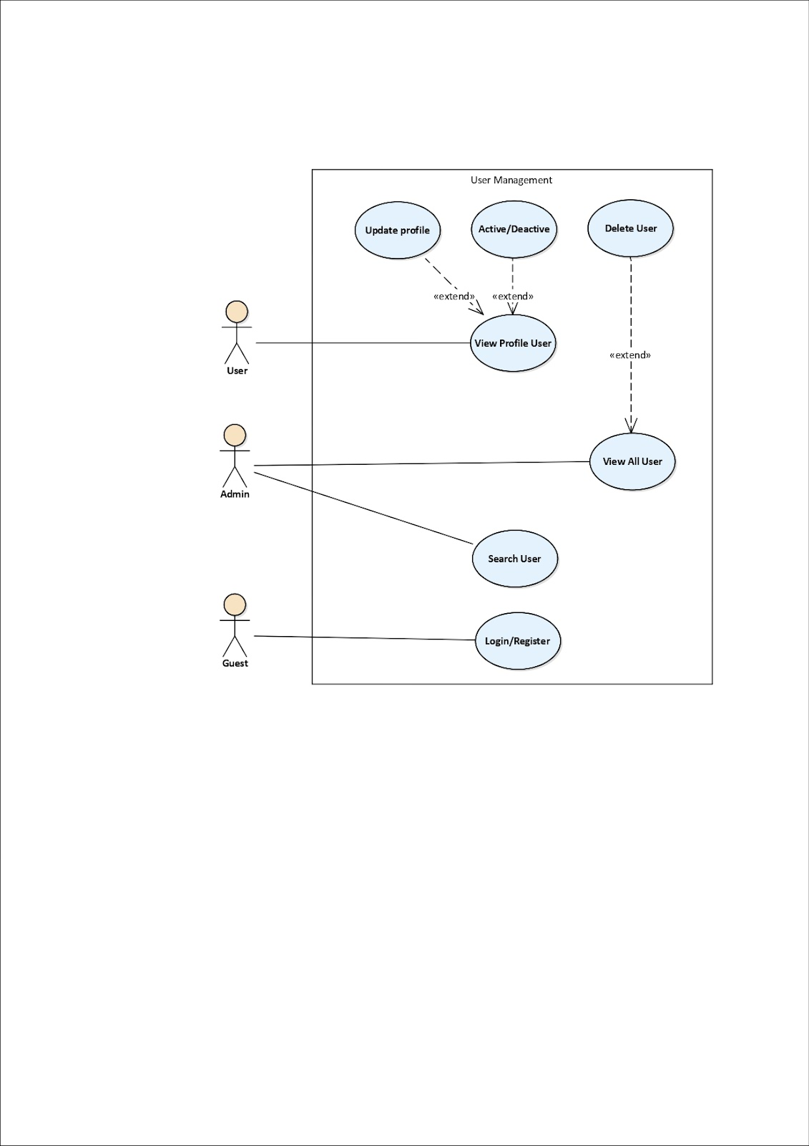

Figure 3‑4. User management use case diagram

#### **3.3.1.2. Media management use case diagram**

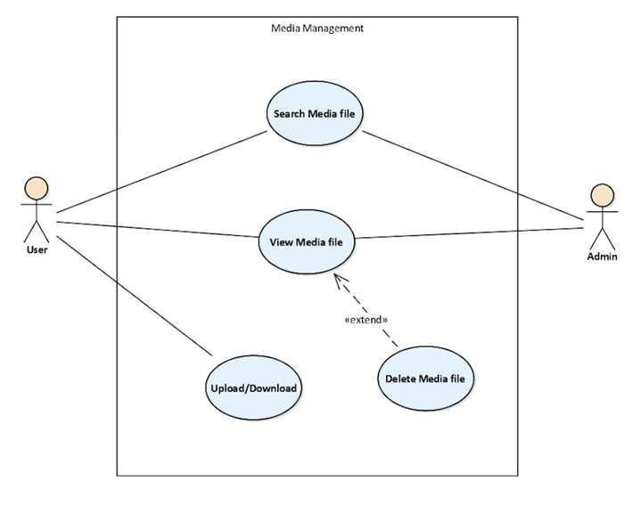

Figure 3‑5. Media management use case diagram

#### **3.3.1.3. Post management use case diagram**

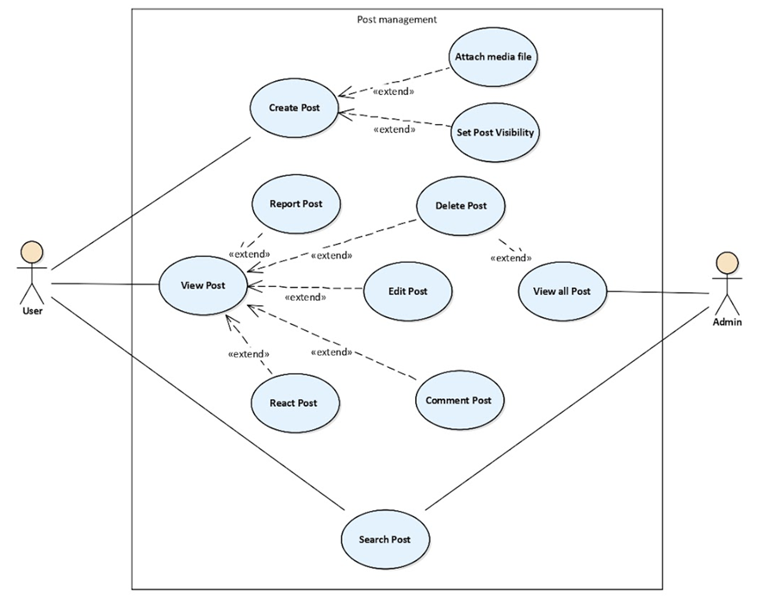

**Figure 3‑6. Post management use case diagram**

#### **3.3.1.4. Friend management use case diagram**

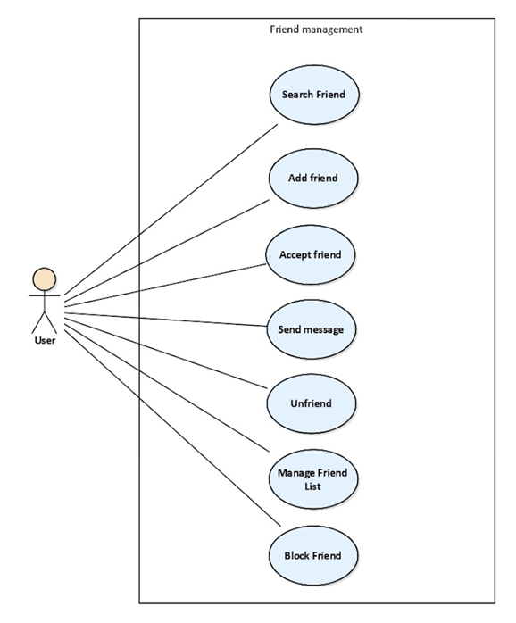

Figure 3‑7. Friend management use case diagram

### **3.3.2. Use case specifications**

#### **3.3.2.1. Use case Register (UC-1)**

|  |  |
| --- | --- |
| Use case ID | UC-1 |
| Use Case Name | Register |
| Short Description | Allows a user or guest to register a new account on the platform. |
| Actor | User, Guest |
| Pre-conditions | None |
| Post-Conditions | Actor registers account successfully |
| Main Flow | 1. Actor click ‘Register’ button  2. The system returns register page.  3. Actor fills all input box (account register & profile)  4. The system authenticates email, password and notifies “Registration Success” and returns login page. |

Table 3‑17. Use case Register (UC-1)

#### **3.3.2.2. Use case Login (UC-2)**

|  |  |
| --- | --- |
| Use case ID | UC-2 |
| Use Case Name | Login |
| Short Description | Allows a user to log in to their existing account. |
| Actor | User |
| Pre-conditions | The user must have an existing account. |
| Post-Conditions | The user is successfully logged in and directed to the dashboard or home page. |
| Main Flow | 1. Actor clicks the ‘Login’ button. 2. The system displays the login form. 3. Actor enters the email and password. 4. The system validates the credentials. 5. If valid, the system authenticates the user and redirects to the dashboard or home page. 6. If invalid, the system displays an error message. |

Table 3‑18. Use case Login (UC-2)

#### **3.3.2.3. Use case Change password (UC-3)**

|  |  |
| --- | --- |
| Use case ID | UC-3 |
| Use Case Name | Change Password |
| Short Description | Allows a user to change their password after logging in. |
| Actor | User |
| Pre-conditions | The user must be logged in and have access to the account settings. |
| Post-Conditions | The user’s password is successfully updated. |
| Main Flow | 1. Actor clicks on the ‘Change Password’ option. 2. The system prompts the user to enter the current password, new password, and confirm the new password. 3. Actor enters the required information. 4. The system validates the current password and ensures the new password meets the required criteria. 5. If valid, the system updates the password and confirms the change. 6. If invalid, the system displays an error message (e.g., incorrect current password, password mismatch,…) |

Table 3‑19. Use case Change password (UC-3)

#### **3.3.2.4. Use case Log out (UC-4)**

|  |  |
| --- | --- |
| Use case ID | UC-4 |
| Use Case Name | Log Out |
| Short Description | Allows a logged-in user to log out of their account. |
| Actor | User |
| Pre-conditions | The user must be logged in to their account. |
| Post-Conditions | The user is logged out and redirected to the login page. |
| Main Flow | 1. Actor clicks the ‘Log Out’ button or selects ‘Log Out’ from the account menu. 2. The system logs out the user, clearing the session or authentication token. 3. The system redirects the user to the login page. |

Table 3‑20. Use case Log out (UC-4)

#### **3.3.2.5. Use case Change profile’s user (UC-5)**

|  |  |
| --- | --- |
| Use case ID | UC-5 |
| Use Case Name | Change Profile's User |
| Short Description | Allows a user to update their profile information (e.g., name, profile picture, bio). |
| Actor | User |
| Pre-conditions | The user must be logged in and have access to their profile settings. |
| Post-Conditions | The user’s profile is successfully updated with the new information. |
| Main Flow | 1. Actor navigates to the ‘Admin page’ and choice tab ‘User’  2. Actor clicks on the ‘Edit’ button to modify profile details. 3. The system displays editable fields (e.g., name, profile picture, bio). 4. Actor updates the required information. 5. The system validates the input (e.g., ensures profile picture is a valid file format, name is not empty). 6. If valid, the system updates the profile and shows a confirmation message. 7. If invalid, the system displays an error message (e.g., invalid file format or empty fields). |

Table 3‑21. Use case Change profile’s user (UC-5)

#### **3.3.2.6. Use case Create/Edit/Delete Post (UC-6)**

|  |  |
| --- | --- |
| Use case ID | UC-6 |
| Use Case Name | Create Post |
| Short Description | Allows a user to post a new post or delete an existing post. |
| Actor | User |
| Pre-conditions | The user must be logged in and have access to the posting or their own posts. |
| Post-Conditions | The post is successfully created or deleted. |
| Main Flow | 1. Actor click on box create new post. 2. Actor fills in the content for the post (e.g., text, image, or link).  3. System upload all images to cloudinary  4. If valid, the system creates the post and displays a success message. 5. The post is now visible in the user's timeline or feed. 7. If invalid, the system displays an error message (e.g., invalid file format or empty fields). |

Table 3‑22. Use case Create Post (UC-6)

|  |  |
| --- | --- |
| Use case ID | UC-6 |
| Use Case Name | Edit Post |
| Short Description | Allows a user to edit an existing post. |
| Actor | User |
| Pre-conditions | The user must be logged in and have access to the posting or their own posts. |
| Post-Conditions | The post is successfully edited. |
| Main Flow | 1. Actor click on post that user want to edit.  2. Dalog appear and allowing user edit. 3. If valid, the system edit content of the post and displays a success message. 4. The post is now appears in the user's timeline or feed with new content. 5. If invalid, the system displays an error message. |

Table 3‑23. Use case Edit Post (UC-6)

|  |  |
| --- | --- |
| Use case ID | UC-6 |
| Use Case Name | Delete Post |
| Short Description | Allows a user to delete an existing post. |
| Actor | User |
| Pre-conditions | The user must be logged in and have access to the posting or their own posts. |
| Post-Conditions | The post is successfully deleted. |
| Main Flow | 1. Actor click on post that user want to remove.  2. Dialog confirm that user delete post 3. If valid, the system delete the post and displays a success message. 4. The post is now disappear in the user's timeline or feed. 5. If invalid, the system displays an error message. |

Table 3‑24. Use case Delete Post (UC-6)

#### **3.3.2.7. Use case Comment Post (UC-7)**

|  |  |
| --- | --- |
| Use case ID | UC-7 |
| Use Case Name | Comment Post |
| Short Description | Allows a user to comment on a post. |
| Actor | User |
| Pre-conditions | The user must be logged in and the post must exist. |
| Post-Conditions | The comment is successfully added to the post. |
| Main Flow | 1. Actor navigates to the post they wish to comment on. 2. Actor clicks the ‘Comment’ button. 3. The system displays a comment input box. 4. Actor enters the comment and submits it. 5. If valid, the system adds the comment to the post and displays it. 6. If invalid, the system displays an error message. |

Table 3‑25. Use case Comment Post (UC-7)

#### **3.3.2.8. Use case Reaction Post (UC-8)**

|  |  |
| --- | --- |
| Use case ID | UC-8 |
| Use Case Name | Reaction Post |
| Short Description | Allows a user to react (like, love, etc.) to a post. |
| Actor | User |
| Pre-conditions | The post receives a new reaction from the user. |
| Post-Conditions | The post receives a new reaction from the user. |
| Main Flow | 1. Actor navigates to the post they wish to react to. 2. Actor selects a reaction (e.g., like, love, etc.). 3. The system validates the reaction. 4. If valid, the system records the reaction and updates the post’s reaction count. 5. If invalid, the system displays an error message. |

Table 3‑26. Use case Reaction Post (UC-8)

#### **3.3.2.9. Use case In-Active account user (UC-9)**

|  |  |
| --- | --- |
| Use case ID | UC-9 |
| Use Case Name | In-Active Account User |
| Short Description | Allows the system to mark an account as inactive if the user has not logged in for a period of time. |
| Actor | Admin |
| Pre-conditions | The user has not logged in for a specified period of time. |
| Post-Conditions | The account is marked as inactive and the user may not be able to perform actions. |
| Main Flow | 1. The system checks the last login time of the user. 2. If the user has been active for the specified period, the system marks the account as inactive. 3. The system notifies the user of the account status change. |

Table 3‑27. Use case In-Active account user (UC-9)

#### **3.3.2.10. Use case Delete account user (UC-10)**

|  |  |
| --- | --- |
| Use case ID | UC-10 |
| Use Case Name | Delete Account User |
| Short Description | Allows a user to permanently delete their account. |
| Actor | Admin |
| Pre-conditions | The user must be logged in and have access to admin settings. |
| Post-Conditions | The user’s account is deleted from the system. |
| Main Flow | 1. Actor navigates to the ‘Admin Settings’ page and choice ‘User’ tab. 2. Actor selects the ‘Delete Account’ icon option. 3. The system prompts the user to confirm the deletion. 4. Actor confirms the deletion. 5. The system permanently deletes the user’s account and all associated data. |

Table 3‑28. Use case Delete account user (UC-10)

#### **3.3.2.11. Use case Send Message (Chatting) (UC-11)**

|  |  |
| --- | --- |
| Use case ID | UC-11 |
| Use Case Name | Send Message |
| Short Description | Allows a user to send a message to another user. |
| Actor | User |
| Pre-conditions | The user must be logged in and have access to the messaging feature. |
| Post-Conditions | The message is successfully sent to the recipient. |
| Main Flow | 1. Actor navigates to the messaging interface. 2. Actor selects the user recipient. 3. Actor types the message. 4. Actor sends the message. 5. If valid, the message is sent and appears in the recipient’s inbox. 6. If invalid, the system displays an error message. |

Table 3‑29. Use case Send Message (Chatting) (UC-11)

#### **3.3.2.12. Use case Follow/Unfollow user (UC-12)**

|  |  |
| --- | --- |
| Use case ID | UC-12 |
| Use Case Name | Follow/Unfollow User |
| Short Description | Allows a user to follow or unfollow another user’s profile. |
| Actor | User |
| Pre-conditions | The user must be logged in and the other user’s profile must exist. |
| Post-Conditions | The user is now following or no longer following the other user. |
| Main Flow | 1. Actor navigates to the friend page they wish to follow/unfollow. 2. Actor clicks the ‘Follow’ or ‘Unfollow’ button. 3. The system validates the action. 4. If valid, the system updates the following status and displays a success message. 5. If invalid, the system displays an error message. |

Table 3‑30. Use case Follow/Unfollow user (UC-12)

#### **3.3.2.13. Use case Save Post Items (UC-13)**

|  |  |
| --- | --- |
| Use case ID | UC-13 |
| Use Case Name | Save Post Items |
| Short Description | Allows a user to save a post for future reference (bookmark or save to a collection). |
| Actor | User |
| Pre-conditions | The user must be logged in and the post must exist. |
| Post-Conditions | The post is saved to the default folder of user |
| Main Flow | 1. Actor navigates to the post they wish to save. 2. Actor clicks on the ‘Save items’ button. 3. The system saves the post to default folder of user.  4. The system shows a confirmation message indicating the post has been saved. 5. The post can be accessed from the user’s saved items in the future. |

Table 3‑31. Use case Save Post Items (UC-13)

#### **3.3.2.14. Use case Change folder for post (UC-14)**

|  |  |
| --- | --- |
| Use case ID | UC-14 |
| Use Case Name | Change Folder for Post |
| Short Description | Allows a user to move a post to a different folder or collection for organization. |
| Actor | User |
| Pre-conditions | The user must be logged in, and the post must be in a folder. |
| Post-Conditions | The post is successfully moved to the new folder. |
| Main Flow | 1. Navigate to any existing folder of user 2. Actor selects the post and clicks on the ‘Move’ button. 3. The system validates the action. 4. If valid, the system moves the post to the selected folder and shows a confirmation message. 5. If invalid, the system displays an error message (e.g., folder not available). |

Table 3‑32. Use case Change folder for post (UC-14)

#### **3.3.2.15. Use case Create folder for post (UC-15)**

|  |  |
| --- | --- |
| Use case ID | UC-15 |
| Use Case Name | Create Folder for Post |
| Short Description | Allows a user to create a new folder to organize posts. |
| Actor | User |
| Pre-conditions | The user must be logged in and have access to the post management feature. |
| Post-Conditions | A new folder is created and available to store posts. |
| Main Flow | 1. Actor navigates to the post management or folder organization page. 2. Actor clicks on the ‘Create New Folder’ button. 3. The system prompts the user to enter a name for the new folder. 4. Actor enters the folder name and clicks ‘Create’. 5. The system validates the folder name (e.g., checks for duplicates or invalid characters). 6. If valid, the system creates the new folder and displays it in the list of folders. 7. If invalid, the system displays an error message and prompts the user to re-enter the folder name. |

Table 3‑33. Use case Create folder for post (UC-15)

# **CHAPTER 4. SYSTEM DESIGN**

## **4.1. Sequence Diagrams**

### **4.1.1. Login**

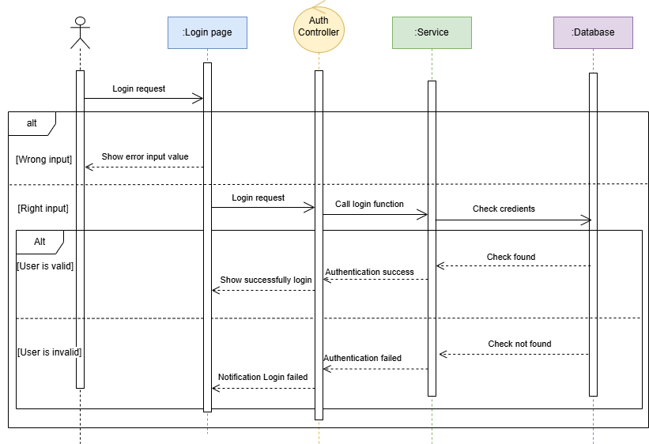

Figure 4‑1. Login Sequence Diagram

### **4.1.2. Register**

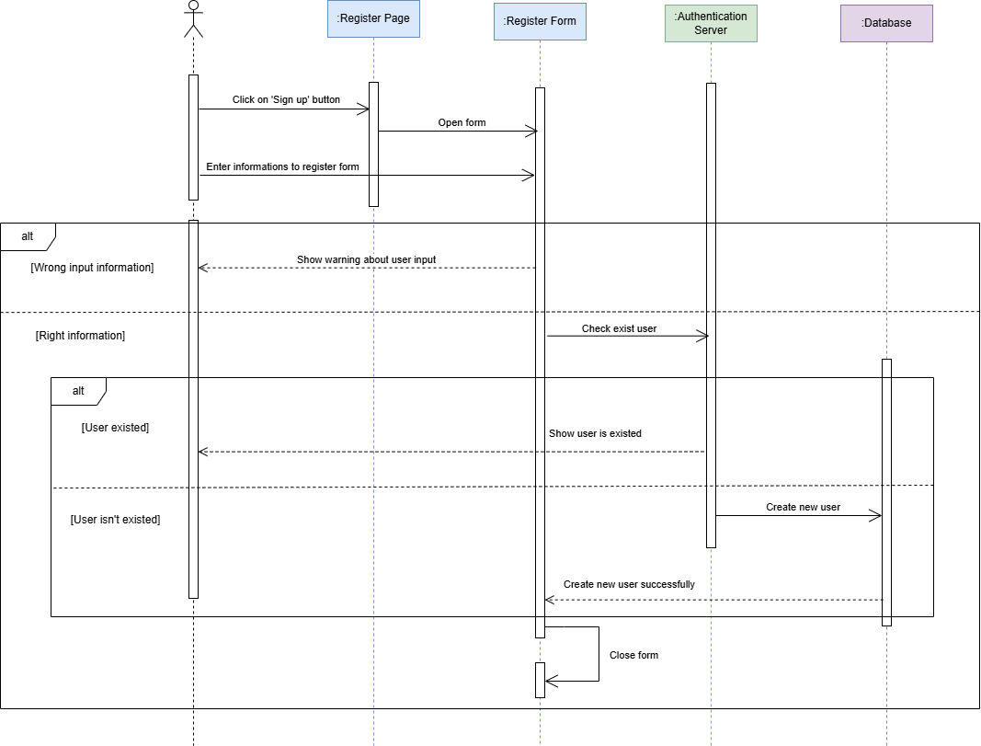

Figure 4‑2. Register Sequence Diagram

### **4.1.3. Create New Profile**

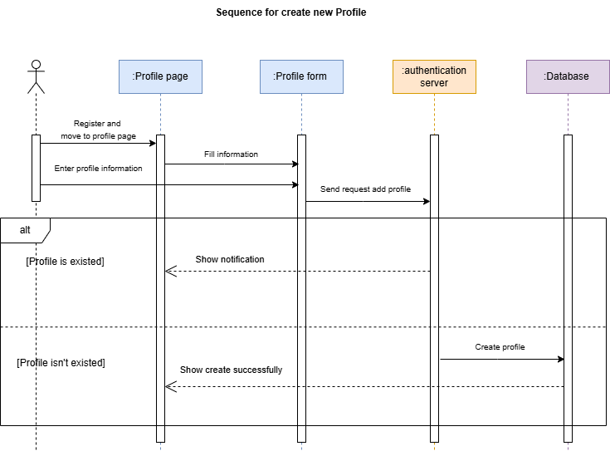

Figure 4‑3. Create New Profile Sequence Diagram

### **4.1.4. Change Profile’s Information**

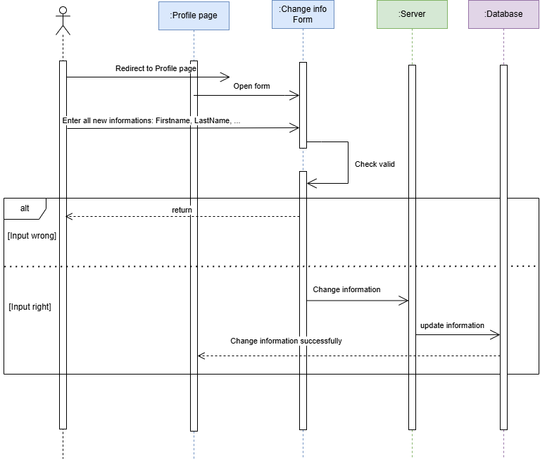

Figure 4‑4. Change Profile Information Sequence Diagram

### **4.1.5. Change Password**

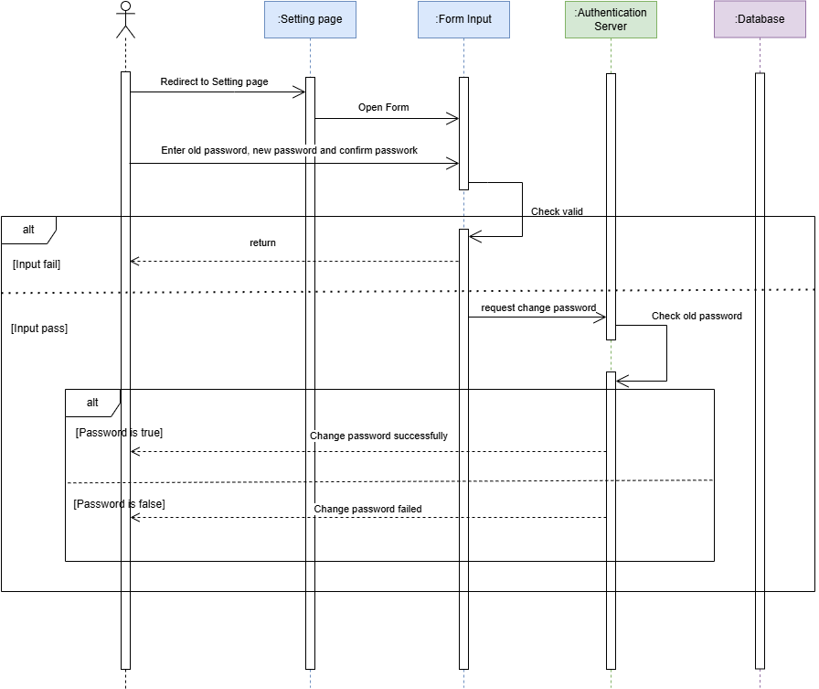

Figure 4‑5. Change Password Sequence Diagram

### **4.1.6. Follow User**

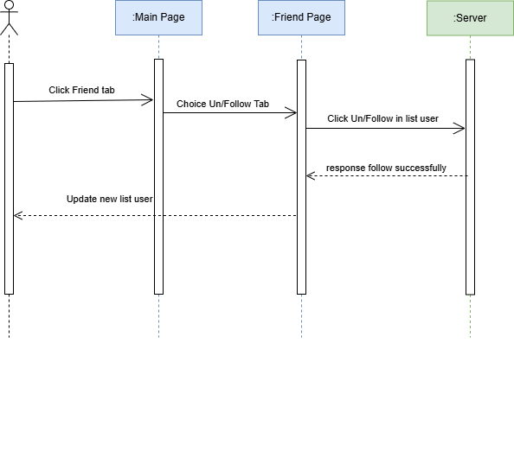

Figure 4‑6. Follow User Sequence Diagram

### **4.1.7. Create New Post**

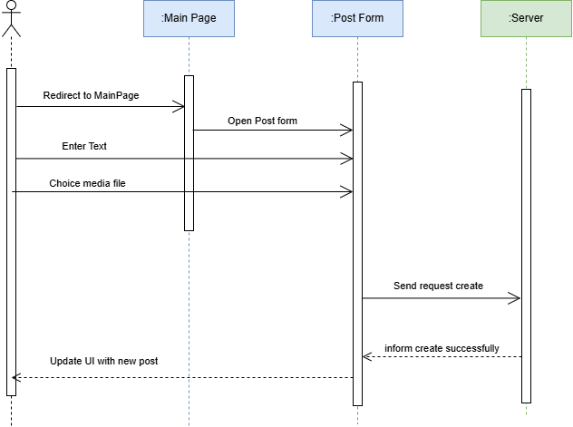

Figure 4‑7. Create New Post Sequence Diagram

### **4.1.8. Edit Post**

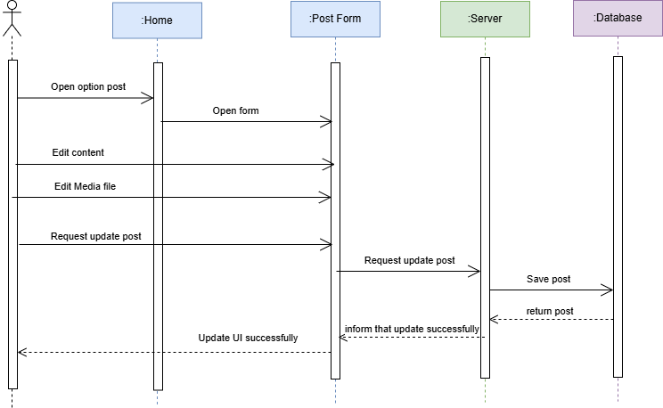

Figure 4‑8. Edit Post Sequence Diagram

### **4.1.9. Reaction**

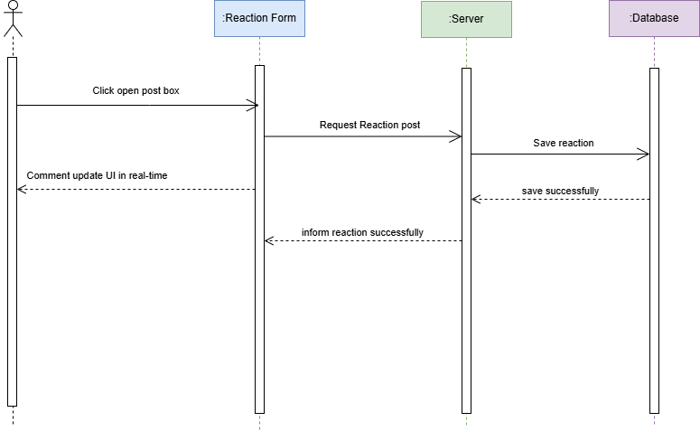

Figure 4‑9. Reaction Sequence Diagram

### **4.1.10. Comment**

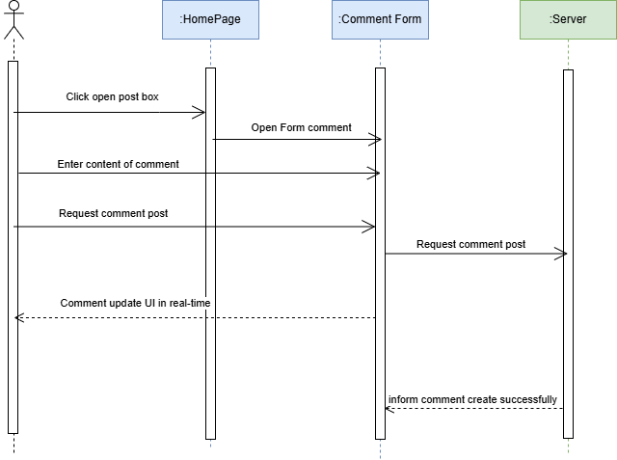

Figure 4‑10. Comment Sequence Diagram

### **4.1.11. Delete Existed Post**

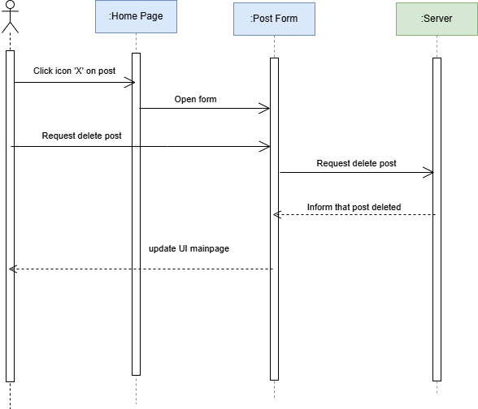

Figure 4‑11. Delete Existed Post Sequence Diagram

### **4.1.12. Add Post To Folder**

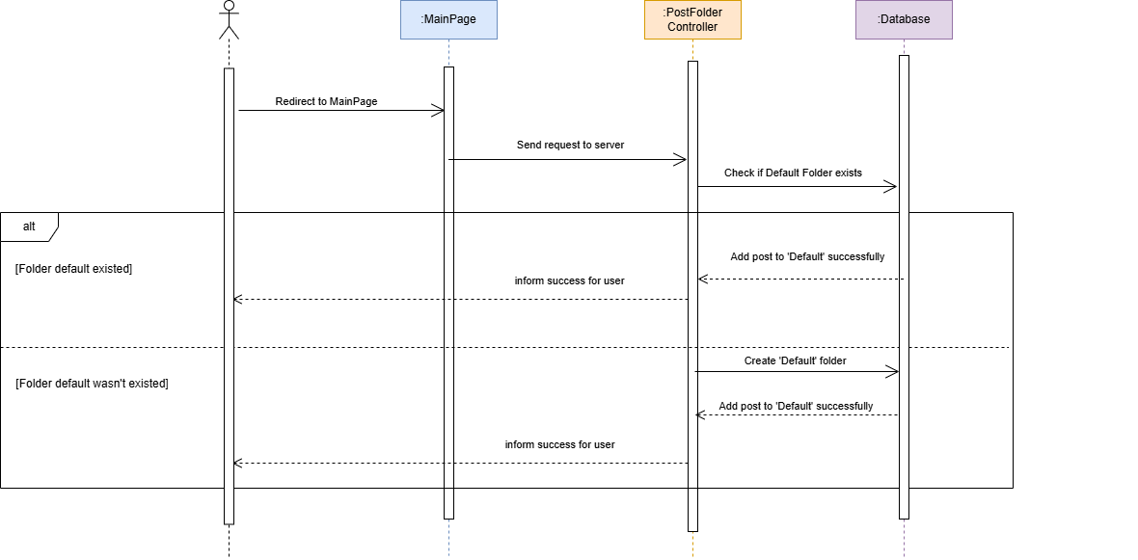

Figure 4‑12. Add Post To Folder Sequence Diagram

### **4.1.13. Create Folder**

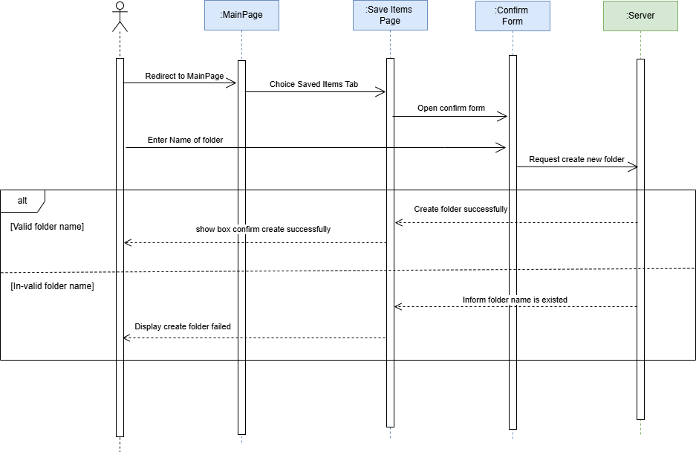

Figure 4‑13. Create Folder Sequence Diagram

### **4.1.14. In-active Account**

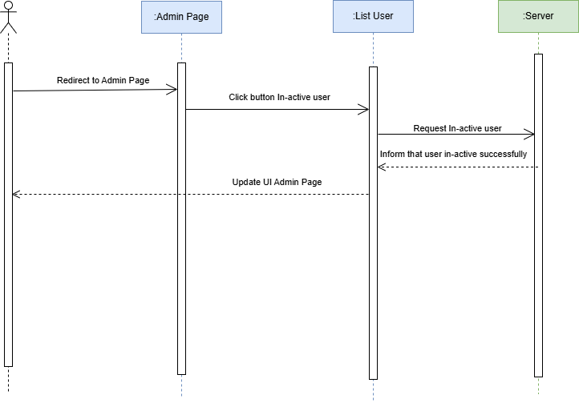

Figure 4‑14. In-Active Account Sequence Diagram

### **4.1.15. Delete Account**

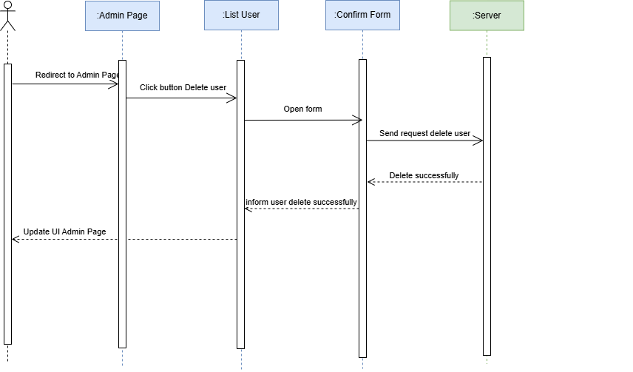

Figure 4‑15. Delete Account Sequence Diagram

### **4.1.16. Chatting**

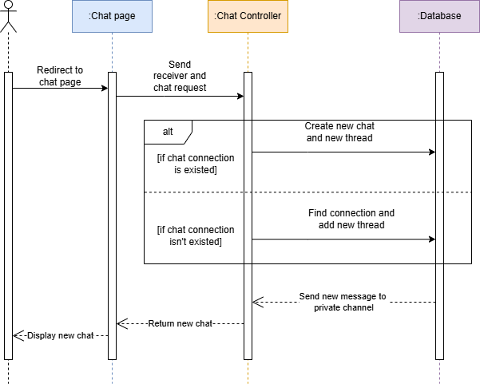

Figure 4‑16. Chatting Sequence Diagram

## **4.2. Database design**

### **4.2.1. Class Diagram**

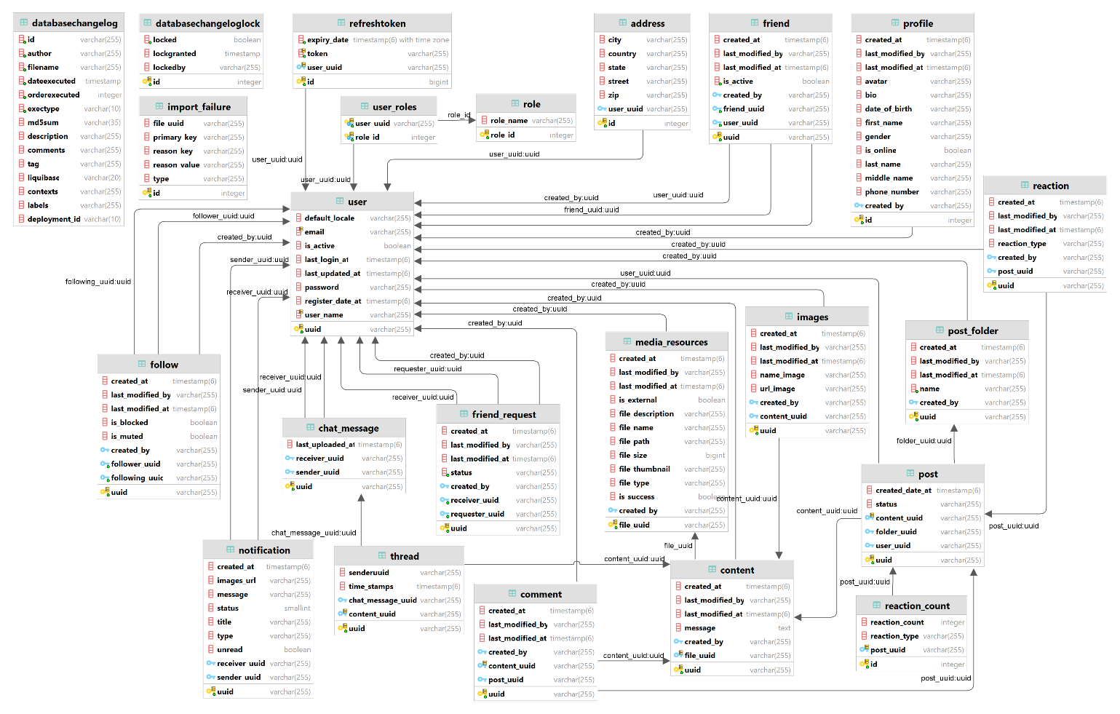

Figure 4‑17. Class Diagram of Social Media System

### **4.2.2. Entity-Relational Database**

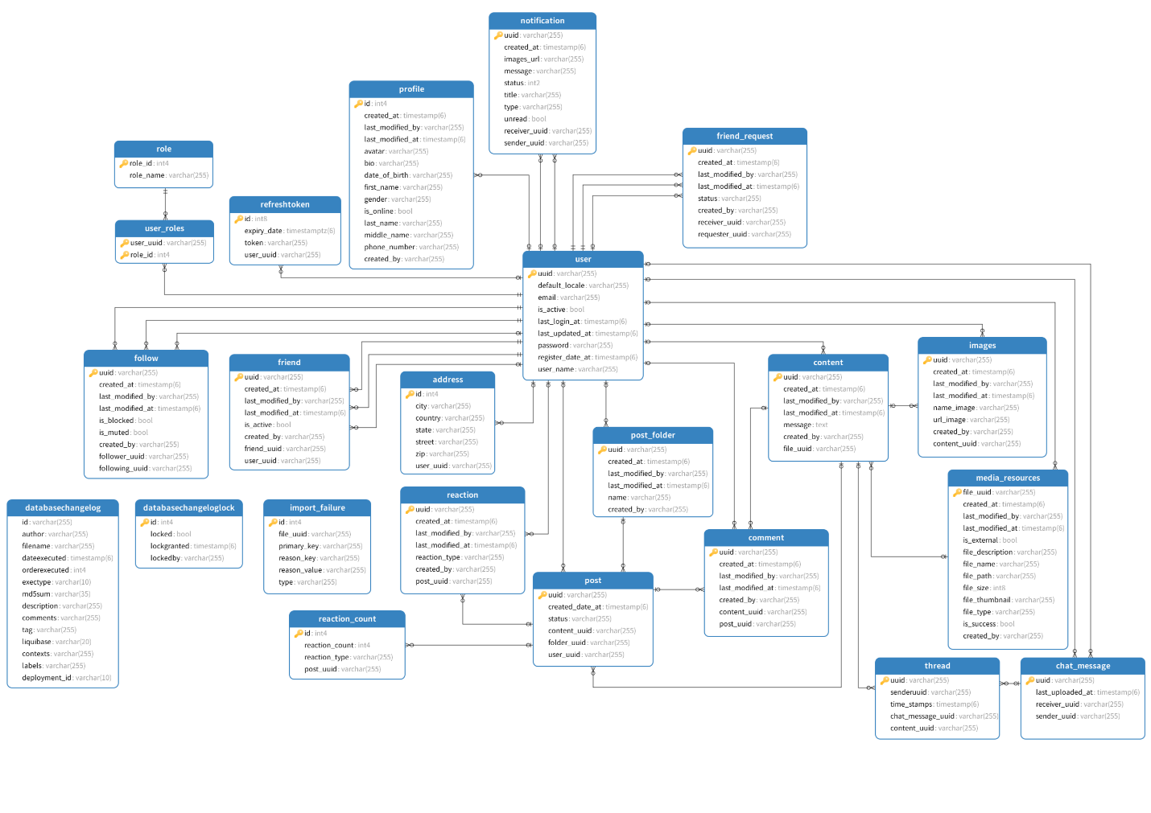

Figure 4‑18. Entity-Relational Database

### 4.2.3. Database Description

#### 4.2.3.1. User Entity

|  |  |  |  |  |  |
| --- | --- | --- | --- | --- | --- |
| **No** | **Attribute** | **Type** | **Range/**  **Contraints** | **Meaning** | **Notes** |
| 1 | uuid | VARCHAR(36) | UUID format | Unique identifier for the user. |  |
| 2 | user_name | VARCHAR | Minimum 2 characters | The username chosen by the user. |  |
| 3 | password | VARCHAR | Minimum 6 characters | The user's account password. |  |
| 4 | email | VARCHAR | Valid email format | Email address of the user. |  |
| 5 | default_locale | VARCHAR | Language/region code (e.g., en) | Default locale for the user, used for localization. |  |
| 6 | is_active | BOOLEAN | True or False | Indicates if the user account is active. |  |
| 7 | register_date_at | TIMESTAMP | Timestamp | Date and time when the user registered. |  |
| 8 | last_login_at | TIMESTAMP | Timestamp | Date and time of the user's last login. |  |
| 9 | last_updated_at | TIMESTAMP | Timestamp | Date and time when the user's details were last updated. |  |

Table 4‑1. User Entity

#### **4.2.3.2. Profile Entity**

|  |  |  |  |  |  |
| --- | --- | --- | --- | --- | --- |
| **No** | **Attribute** | **Type** | **Range/**  **Contrains** | **Meaning** | **Notes** |
| 1 | id | INTEGER | Auto-incremented positive value | Unique identifier for the profile |  |
| 2 | first_name | VARCHAR |  | User's first name |  |
| 3 | middle_name | VARCHAR |  | User's middle name |  |
| 4 | last_name | VARCHAR |  | User's last name |  |
| 5 | gender | VARCHAR | Enum values:  *MALE, FEMALE, OTHER* | Gender of the user. |  |
| 6 | date_of_birth | VARCHAR |  | User's date of birth. |  |
| 7 | bio | VARCHAR |  | User's biography or description. |  |
| 8 | phone_number | VARCHAR |  | User's phone number. |  |
| 9 | avatar | VARCHAR |  | URL or path to the user's avatar. |  |
| 10 | is_online | BOOLEAN | true or false | Indicates if the user is online. |  |

Table 4‑2. Profile Entity

#### **4.2.3.3. Address Entity**

|  |  |  |  |  |  |
| --- | --- | --- | --- | --- | --- |
| **No** | **Attribute** | **Type** | **Range/**  **Contrains** | **Meaning** | **Notes** |
| 1 | id | INTEGER | Auto-incremented positive value | Unique identifier for the address. |  |
| 2 | street | VARCHAR |  | Street address of the user. |  |
| 3 | city | VARCHAR |  | City of the user. |  |
| 4 | state | VARCHAR |  | State or region of the user. |  |
| 5 | zip | VARCHAR |  | ZIP or postal code of the user. |  |
| 6 | country | VARCHAR |  | Country of the user. |  |

Table 4‑3. Address Entity

#### **4.2.3.4. Role Entity**

|  |  |  |  |  |  |
| --- | --- | --- | --- | --- | --- |
| **No** | **Attribute** | **Type** | **Range/**  **Contrains** | **Meaning** | **Notes** |
| 1 | role_id | INTEGER |  | Unique identifier for the role. |  |
| 2 | role_name | VARCHAR | ERole values:  *ROLE_USER***,** *ROLE_ADMIN* | Name of role |  |

Table 4‑4. Role Entity

#### **4.2.3.5. Post Entity**

|  |  |  |  |  |  |
| --- | --- | --- | --- | --- | --- |
| **No** | **Attribute** | **Type** | **Range/**  **Contrains** | **Meaning** | **Notes** |
| 1 | uuid | VARCHAR(36) |  | Unique identifier for the post. |  |
| 2 | status |  | EstatusPost:  *PUBLIC***,** *PRIVATE***,** *FRIENDS* | Status of the post. |  |
| 3 | created_date_at | TIMESTAMP | Timestamp | Timestamp when the post was created. |  |
| 4 | content_uuid | VARCHAR(36) | Matches UUID in Content table | References the associated content. |  |
| 5 | folder_uuid | VARCHAR(36) | Matches UUID in PostFolder table |  |  |
| 6 | user_uuid | VARCHAR(36) | Matches UUID in User table | References the author of the post. |  |

Table 4‑5. Post Entity

#### **4.2.3.5. Content Entity**

|  |  |  |  |  |  |
| --- | --- | --- | --- | --- | --- |
| **No** | **Attribute** | **Type** | **Range/**  **Contrains** | **Meaning** | **Notes** |
| 1 | uuid | VARCHAR(36) | Auto-generated UUID | Unique identifier for the content. |  |
| 2 | file_uuid | VARCHAR(36) | Matches file_UUID in MediaResources table | References the associated media resource. |  |
| 3 | message | TEXT |  | Text message or description of the content. |  |

Table 4‑6. Content Entity

#### **4.2.3.6. Reaction Entity**

|  |  |  |  |  |  |
| --- | --- | --- | --- | --- | --- |
| **No** | **Attribute** | **Type** | **Range/**  **Contrains** | **Meaning** | **Notes** |
| 1 | uuid | VARCHAR(36) | Auto-generated UUID | Unique identifier for the reaction. |  |
| 2 | post_UUID | VARCHAR(36) | Matches UUID in Post table | References the post being reacted to. |  |
| 3 | reaction_type | VARCHAR | Ereaction:  *LIKE*,  *HAHA,**WOW,*  *SAD,**ANGRY,*  *LOVE* | Type of reaction (e.g., like, love). |  |

Table 4‑7. Reaction Entity

#### **4.2.3.7. Comment Entity**

|  |  |  |  |  |  |
| --- | --- | --- | --- | --- | --- |
| **No** | **Attribute** | **Type** | **Range/**  **Contrains** | **Meaning** | **Notes** |
| 1 | uuid | VARCHAR(36) | Auto-generated UUID | Unique identifier for the comment. |  |
| 2 | post_UUID | VARCHAR(36) | Matches UUID in Post table | References the post the comment belongs to. |  |
| 3 | content_uuid | VARCHAR(36) | Matches UUID in Content table | References the content of the comment. |  |

Table 4‑8. Comment Entity

#### **4.2.3.8. Image Entity**

|  |  |  |  |  |  |
| --- | --- | --- | --- | --- | --- |
| **No** | **Attribute** | **Type** | **Range/**  **Contrains** | **Meaning** | **Notes** |
| 1 | uuid | VARCHAR(36) | Auto-generated UUID | Unique identifier for the Image. |  |
| 2 | name_image | VARCHAR |  | The name of the image. |  |
| 3 | url_image | VARCHAR |  | URL or path to the image. |  |
| 4 | content_uuid | VARCHAR |  | References the content this image belongs to. |  |

Table 4‑9. Image Entity

#### **4.2.3.9. Follow Entity**

|  |  |  |  |  |  |
| --- | --- | --- | --- | --- | --- |
| **No** | **Attribute** | **Type** | **Range/**  **Contrains** | **Meaning** | **Notes** |
| 1 | uuid | VARCHAR(36) | Auto-generated UUID | Unique identifier for the follow record. |  |
| 2 | is_blocked | BOOLEAN | true or false | Indicates if the follower has blocked the following user. |  |
| 3 | is_muted | BOOLEAN | true or false | Indicates if the follower has muted the following user. |  |
| 4 | follower_uuid | VARCHAR(36) | Matches UUID in User table | References the user who is following another user. |  |
| 5 | following_uuid | VARCHAR(36) | Matches UUID in User table | References the user being followed. |  |

Table 4‑10. Follow Entity

#### **4.2.3.10. Friend Entity**

|  |  |  |  |  |  |
| --- | --- | --- | --- | --- | --- |
| **No** | **Attribute** | **Type** | **Range/**  **Contrains** | **Meaning** | **Notes** |
| 1 | uuid | VARCHAR(36) | Auto-generated UUID | Unique identifier for the friendship record. |  |
| 2 | user_uuid | VARCHAR(36) | Matches UUID in User table | References the current user in the friendship. |  |
| 3 | friend_uuid | VARCHAR(36) | Matches UUID in User table | References the friend of the current user. |  |
| 4 | is_active | BOOLEAN | true or false | Indicates if the friendship is active. |  |

Table 4‑11. Friend Entity

#### **4.2.3.11. FriendRequest Entity**

|  |  |  |  |  |  |
| --- | --- | --- | --- | --- | --- |
| **No** | **Attribute** | **Type** | **Range/**  **Contrains** | **Meaning** | **Notes** |
| 1 | uuid | VARCHAR(36) | Auto-generated UUID | Unique identifier for the friend request. |  |
| 2 | requester_uuid | VARCHAR(36) | Matches UUID in User table | References the user who sent the friend request. |  |
| 3 | receiver_uuid | VARCHAR(36) | Matches UUID in User table | References the user who received the friend request. |  |
| 4 | status | VARCHAR(36) | RequestStatus:  *PENDING,*  *ACCEPTED,*  *REJECTED* | Represents the current status of the friend request. |  |

Table 4‑12. FriendRequest Entity

#### **4.2.3.12. MediaResources Entity**

|  |  |  |  |  |  |
| --- | --- | --- | --- | --- | --- |
| **No** | **Attribute** | **Type** | **Range/**  **Contrains** | **Meaning** | **Notes** |
| 1 | file_UUID | VARCHAR(36) | Auto-generated UUID | Unique identifier for the media resource. |  |
| 2 | file_name | VARCHAR(255) |  | The name of the media file. |  |
| 3 | file_type | VARCHAR(255) | EfileType values | The type of the file (e.g., image, video). |  |
| 4 | is_external | BOOLEAN | True/False | Indicates whether the media is external (e.g., hosted outside the application). |  |
| 5 | file_path | VARCHAR(255) |  | The path to the file within the application or storage. |  |
| 6 | file_size | BIGINT | File size in bytes | Size of the file in bytes. |  |
| 7 | file_description | TEXT |  | A brief description of the file content. |  |
| 8 | file_thumbnail | VARCHAR(255) |  | Path or URL to the file's thumbnail image. |  |
| 9 | is_success | BOOLEAN | True/False | Indicates whether the file was uploaded successfully. |  |

Table 4‑13. MediaResources Entity

#### **4.2.3.13. Notification Entity**

|  |  |  |  |  |  |
| --- | --- | --- | --- | --- | --- |
| **No** | **Attribute** | **Type** | **Range/**  **Contrains** | **Meaning** | **Notes** |
| 1 | uuid | VARCHAR(36) |  | Unique identifier for notification. |  |
| 2 | status | VARCHAR |  | The current status of the notification. |  |
| 3 | title | VARCHAR(255) |  | The title of the notification. |  |
| 4 | message | TEXT |  | The message of the notification. |  |
| 5 | imagesUrl | VARCHAR(255) |  | URL of any image(s) with the notification. |  |
| 6 | type | VARCHAR(255) |  | The type of notification. |  |
| 7 | createdAt | TIMESTAMP | Not null | The timestamp when it was created. |  |
| 8 | unread | BOOLEAN |  | Flag indicating whether the notification is unread. |  |
| 9 | sender | VARCHAR(36) | Foreign key referencing User(UUID) | The user who sent the notification. |  |
| 10 | receiver | VARCHAR(36) | Foreign key referencing User(UUID) | The user who receives the notification. |  |

Table 4‑14. Notification Entity

#### **4.2.3.14. PostFolder Entity**

|  |  |  |  |  |  |
| --- | --- | --- | --- | --- | --- |
| **No** | **Attribute** | **Type** | **Range/**  **Contrains** | **Meaning** | **Notes** |
| 1 | uuid | VARCHAR(36) | Auto-generated UUID | Unique identifier for the post folder. |  |
| 2 | name | VARCHAR(255) | Not null | The name of the post folder. |  |

Table 4‑15. PostFolder Entity

#### **4.2.3.15. ChatMessage Entity**

|  |  |  |  |  |  |
| --- | --- | --- | --- | --- | --- |
| **No** | **Attribute** | **Type** | **Range/**  **Contrains** | **Meaning** | **Notes** |
| 1 | uuid | VARCHAR(36) | Auto-generated UUID | Unique identifier for the chat message. |  |
| 2 | sender_uuid | VARCHAR(36) | Foreign key referencing User.UUID | The sender of the chat message |  |
| 3 | receiver_uuid | VARCHAR(36) | Foreign key referencing User.UUID | The receiver of the chat message |  |
| 4 | last_uploaded_at | TIMESTAMP | Timestamp | The timestamp when the chat message was last uploaded. |  |

Table 4‑16. ChatMessage Entity

#### **4.2.3.16. Thread Entity**

|  |  |  |  |  |  |
| --- | --- | --- | --- | --- | --- |
| **No** | **Attribute** | **Type** | **Range/**  **Contrains** | **Meaning** | **Notes** |
| 1 | uuid | VARCHAR(36) | Auto-generated UUID | Unique identifier for the thread. |  |
| 2 | chat_message_uuid | VARCHAR(36) | Foreign key referencing ChatMessage.uuid | The associated chat message for this thread. |  |
| 3 | Sender_uuid | VARCHAR(36) |  | The sender of the thread message. |  |
| 4 | content_uuid | VARCHAR(36) | Foreign key referencing Content.uuid | The content associated with the thread message. |  |
| 5 | timeStamps | TIMESTAMP |  | The timestamp when the thread message was created or modified. |  |

Table 4‑17. Thread Entity

## **4.3. User Interface Design**

|  |  |  |
| --- | --- | --- |
| **No.** | **Screen Name** | **Description** |
| SCU01 | Register screen | User will be forced to fill all of the fields for registering an account |
| SCU02 | Login Screen | Login page for registered users |
| SCU03 | Profile Screen | New user must be filled all of the fields for make user profile |
| SCU04 | Main screen | Show social information, including new posts, user information, notification, follow request recommendations, change languages |
| SCU05 | Following Screen | User can view all users and each user profile and request the following. |
| SCU06 | Feed Screen | User can view all post |
| SCU07 | SaveItem Screen | User can view all save items, create or delete collections |
| SCU08 | Resource Screen | User can view all media files, delete, view detailing and download them |
| SCU09 | Chat Screen | User can view all users, including online and offline users, select and send messages realtime for them. |
| SCU10 | Main friend Management Screen | User can view all users that are not friends and can view the request to add friends, and can send request add friends for others. |
| SCU11 | All Friend Screen | User will view all friends and their profiles. |
| SCU12 | Recommend Friend screen | User will view users that are not friends and their detail profiles |
| SCU13 | Follower Screen | User will view their followers and the detailed profile of each follower. |
| SCU14 | Main Admin Screen | Admin will manager users, posts, edit user profile and delete use |

Table 4‑18. List of User Interface Design

### **4.3.1. Admin Interface**

#### **4.3.1.1. Main Admin Screen (SCU14)**

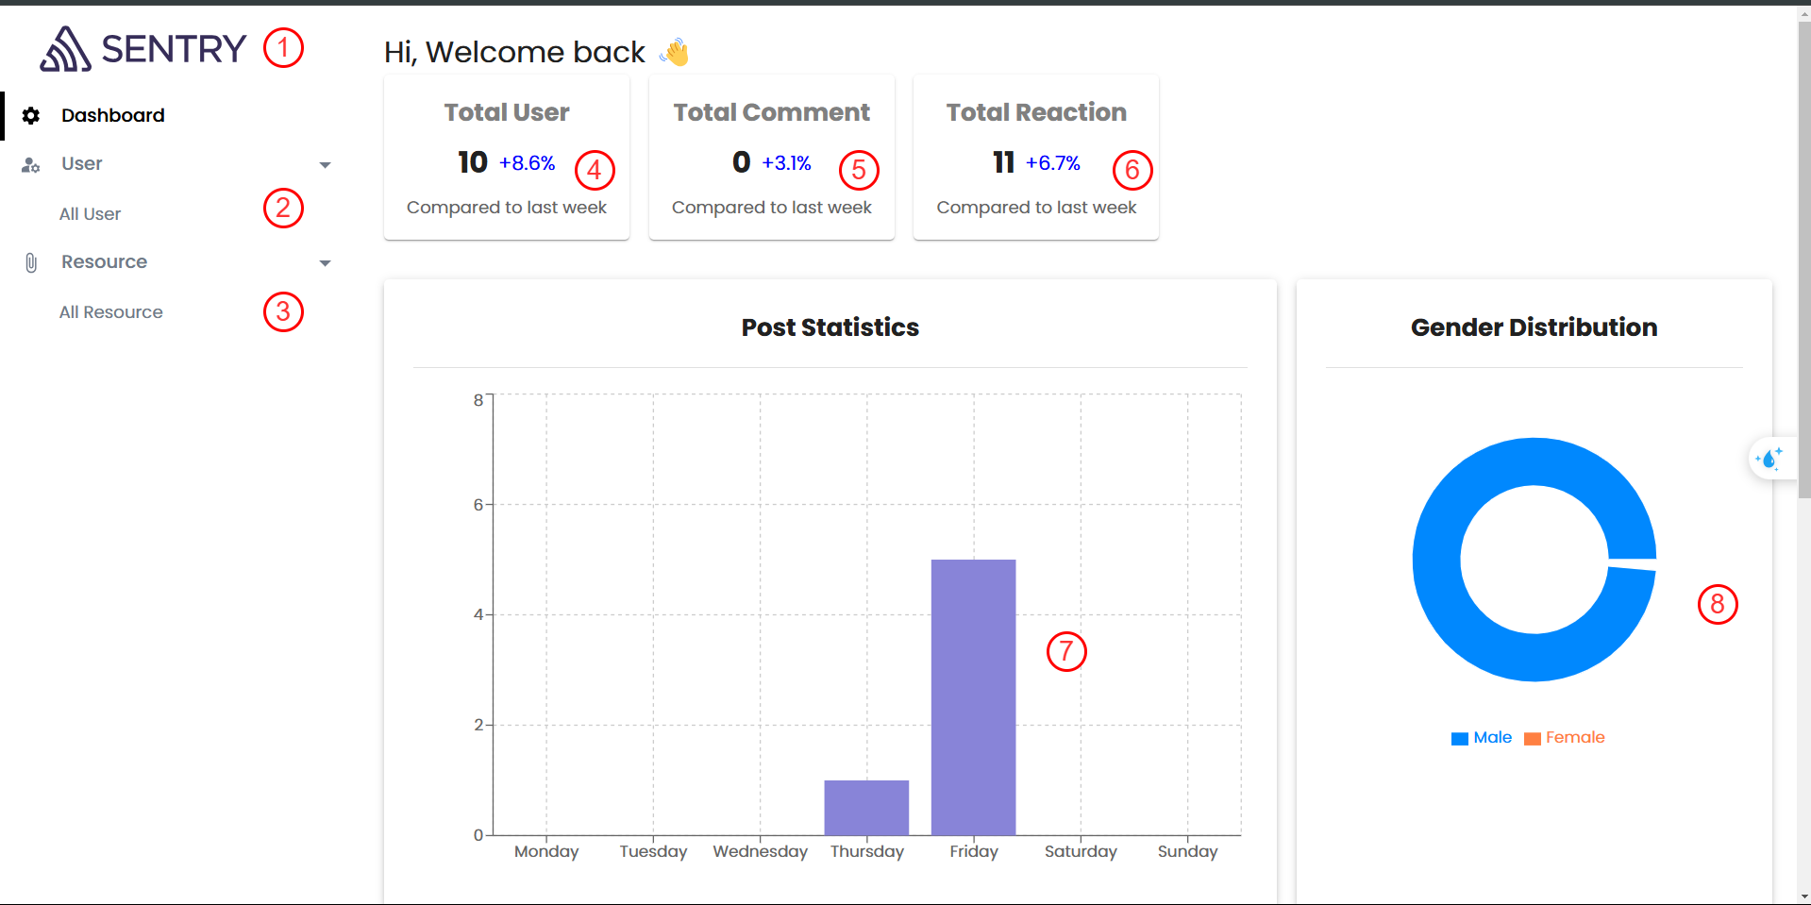

Figure 4‑19. Dashboard Admin Screen

|  |  |  |  |
| --- | --- | --- | --- |
| **No.** | **Name** | **Type** | **Event** |
| 1 | Logo | Button | Back to main screen |
| 2 | AllUser | Button | After clicking, the page goes to user management screen |
| 3 | All Resource | Button | After clicking, the page goes to resource management screen |
| 4 | Total user | TextView | Show total user for admin |
| 5 | Total Comment | TextView | Show total comment |
| 6 | Total reaction | TextView | Show total reaction |
| 7 | Post statistics | Chart | Show statistics all the posts in system |
| 8 | Gender Distribution | Chart | Show distribution of gender of user account |

Table 4‑19. Dashboard Admin Screen

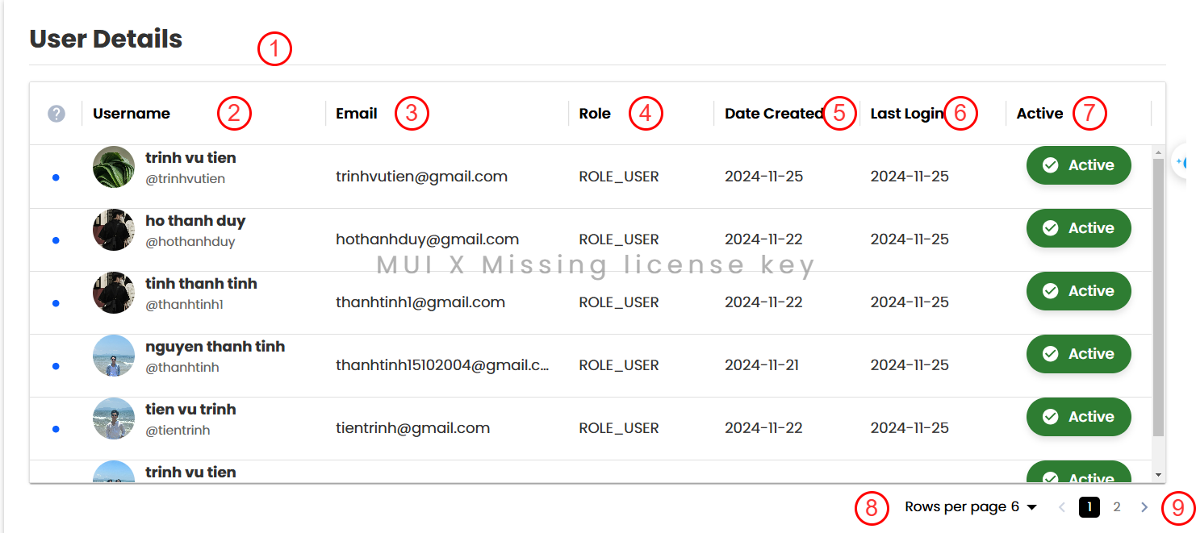

Figure 4‑20. Table of List Active User

|  |  |  |  |
| --- | --- | --- | --- |
| **No.** | **Name** | **Type** | **Event** |
| 1 | User detail | Table | Show all user in system |
| 2 | UserName | Button | Sort by user name |
| 3 | Email | Button | Sort by email |
| 4 | Role | Button | Sort by role |
| 5 | Date Created | Button | Sort by date |
| 6 | Last login | Button | Sort by date |
| 7 | Active | Button | Sort by status |
| 8 | Rows per page | Button | For use change number of users can display in table |
| 9 | narrow | Button | For user can next and back the table user information |

Table 4‑20. Table of List Active User

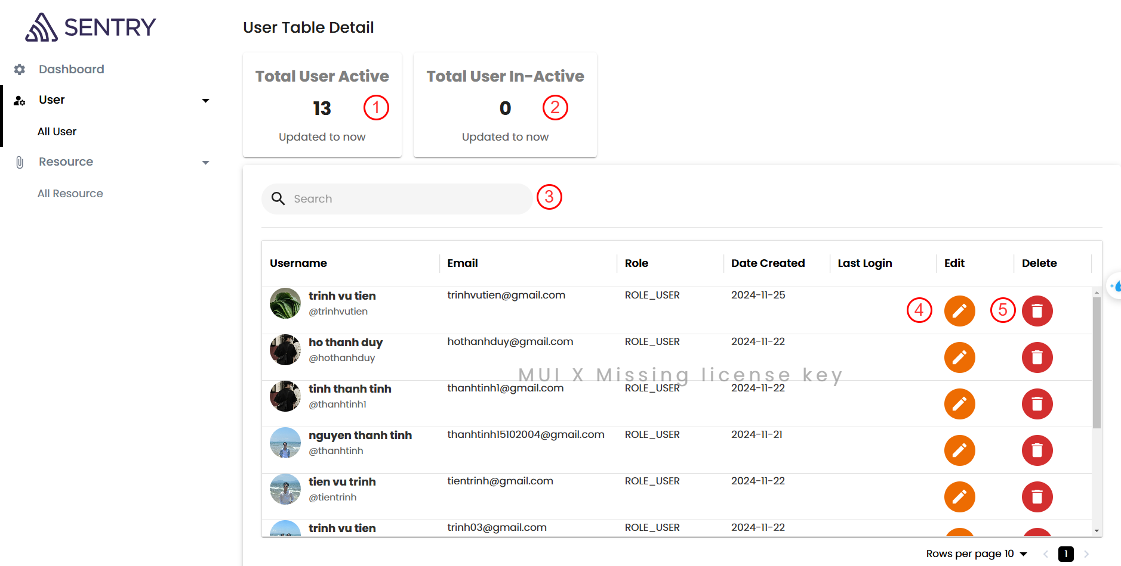

Figure 4‑21. User Management Page

|  |  |  |  |
| --- | --- | --- | --- |
| **No.** | **Name** | **Type** | **Event** |
| 1 | User detail | Table | Show all user in system |
| 2 | UserName | Button | Sort by user name |
| 3 | Email | Button | Sort by email |
| 4 | Role | Button | Sort by role |
| 5 | Date Created | Button | Sort by date |
| 6 | Last login | Button | Sort by date |
| 7 | Active | Button | Sort by status |
| 8 | Rows per page | Button | For use change number of users can display in table |
| 9 | Narrow | Button | For user can next and back the table user information |

Table 4‑21. User Management Page

### **4.3.2. User Interface**

#### **4.3.2.1. Register screen (SCU01)**

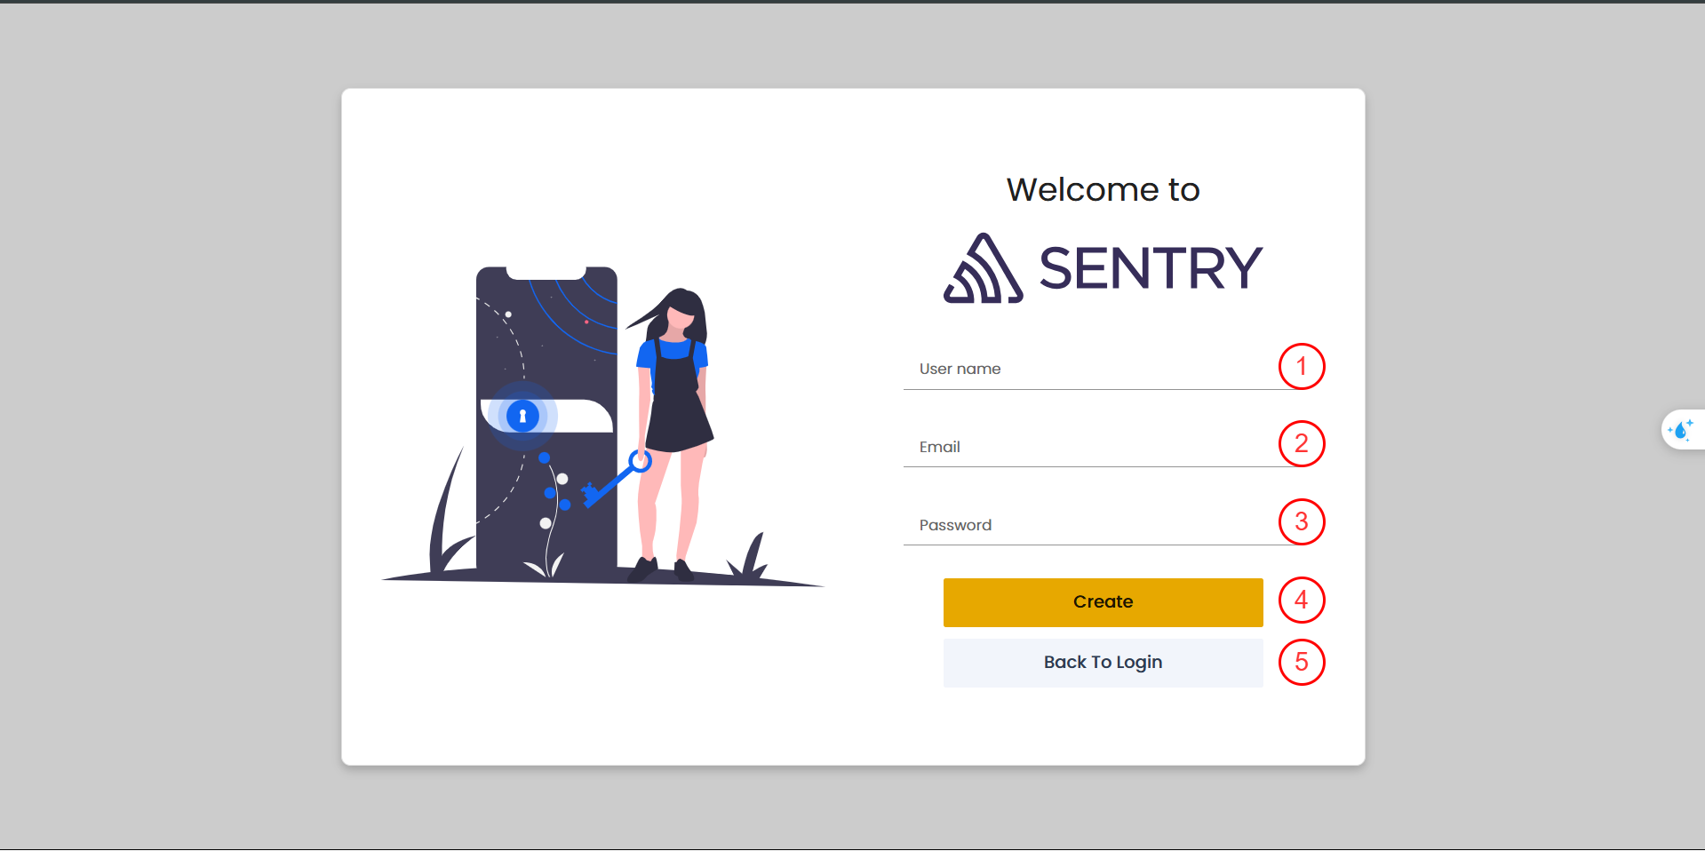

Figure 4‑22. Register screen

|  |  |  |  |
| --- | --- | --- | --- |
| **No.** | **Name** | **Type** | **Event** |
| 1 | UserName | TextBox | For user input username |
| 2 | Email | TextBox | For user input email |
| 3 | Password | TextBox | For user input password |
| 4 | Create | Button | After clicking, new user account will be created and the page goes to profile screen |

Table 4‑22. Register screen

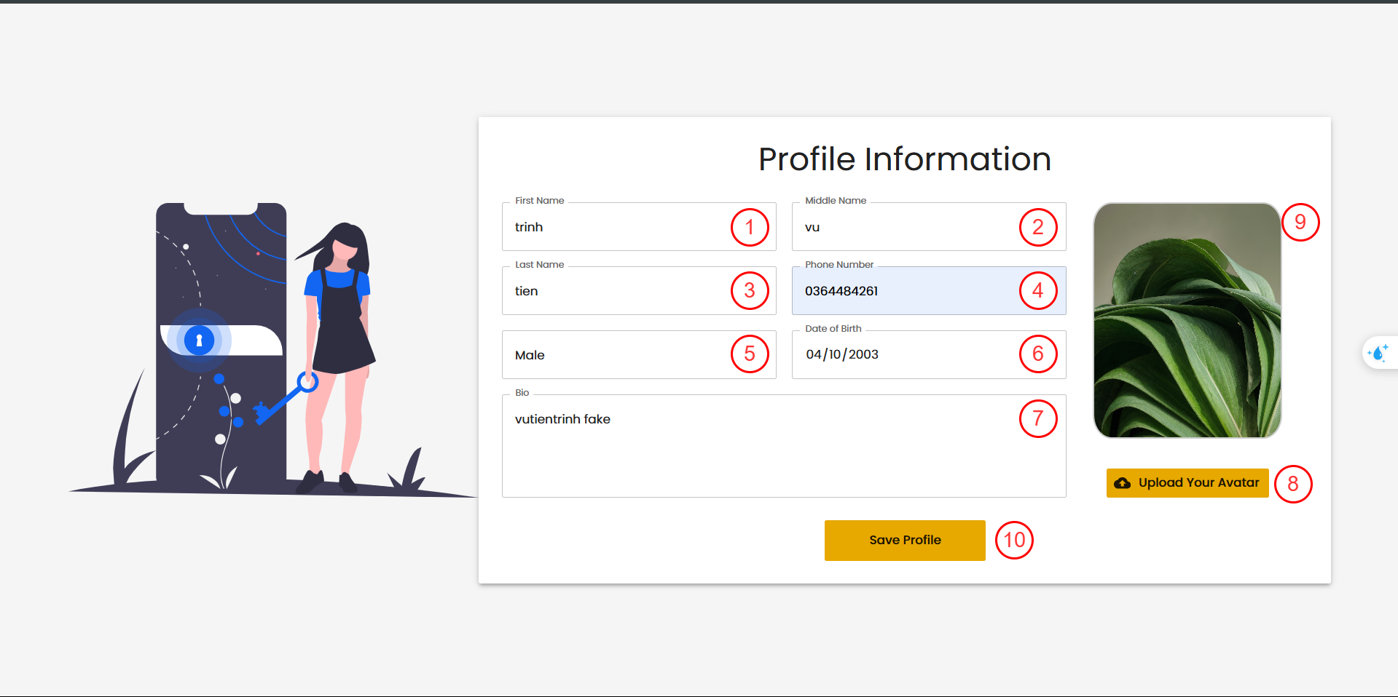

Figure 4‑23. Register Form - Profile Information Page

|  |  |  |  |
| --- | --- | --- | --- |
| **No.** | **Name** | **Type** | **Event** |
| 1 | First name | TexBox | For user input first name |
| 2 | Middle name | TextBox | For user input middle name |
| 3 | Last Name | TextBox | For user input lastname |
| 4 | Phone Number | TextBox | For user input phone number |
| 5 | Male | Selected Box | For user select gender |
| 6 | Date of Birth | Date | For user input date of birth |
| 7 | Bio | TextBox | For user input bio |
| 8 | Upload your Avatar | Button | After clicking, file explorer will be open and user choose your image |
| 9 | Image | Image | Avatar will be display here |
| 10 | Save profile | Button | After clicking, new profile will be saved and the page goes to main screen |

Table 4‑23. Register Form - Profile Information Page

#### **4.3.2.2. Login Screen (SCU02)**

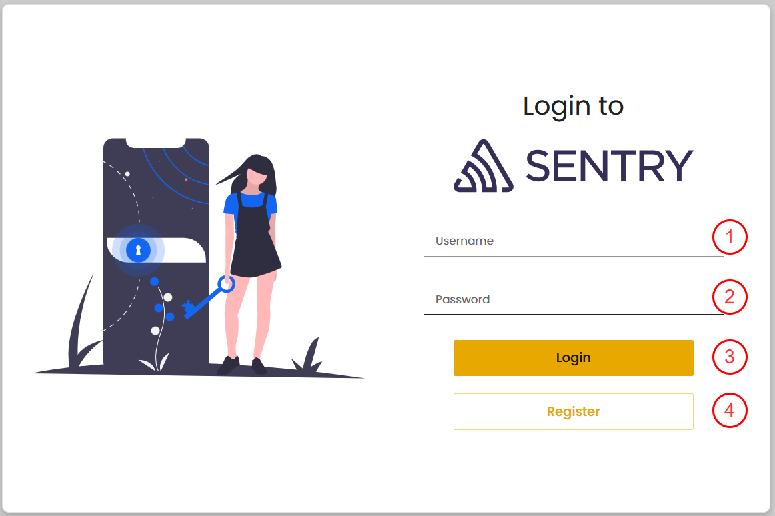

Figure 4‑24. Login Screen

|  |  |  |  |
| --- | --- | --- | --- |
| **No.** | **Name** | **Type** | **Event** |
| 1 | User Name | TextBox | For user to input username |
| 2 | Password | TextBox | For user to input password |
| 3 | Login | Button | After clicking, the page goes to main screen |
| 4 | Register | Button | After clicking, the page goes to Register Screen |

Table 4‑24. Login Screen

#### **4.3.2.4. Main screen (SCU04)**

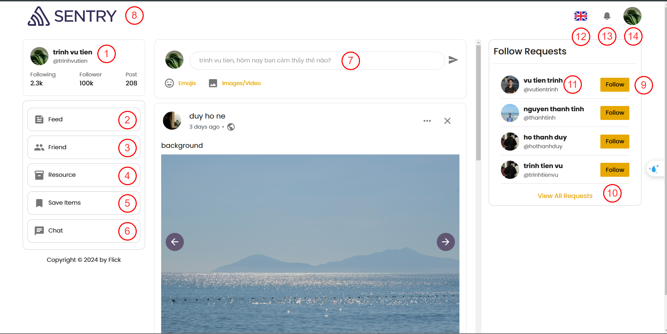

Figure 5‑25. Main Screen

|  |  |  |  |
| --- | --- | --- | --- |
| **No.** | **Name** | **Type** | **Event** |
| 1 | User information | Text | Show name and email of user |
| 2 | Feed | Button | After clicking, the page goes to feed screen |
| 3 | Friend | Button | After clicking, the page goes to friend screen |
| 4 | Resource | Button | After clicking, the page goes to resource screen |
| 5 | Save Items | Button | After clicking, the page goes to Save Items screen |
| 6 | Chat | Button | After clicking, the page goes to chat screen |
| 7 | New post | Box | After clicking, the new post model will be popped up |
| 8 | Logo | Link | After clicking, the page will goes to main screen |
| 9 | Follow | Button | After clicking, user send follow request to another user |
| 10 | View all requests | Link | After clicking, the page goes to following screen |
| 11 | Another user information | Link | after clicking, the page goes to detail profile user screen |

Table 4‑25. Main Screen

#### **4.3.2.6. Feed screen (SCU06)**

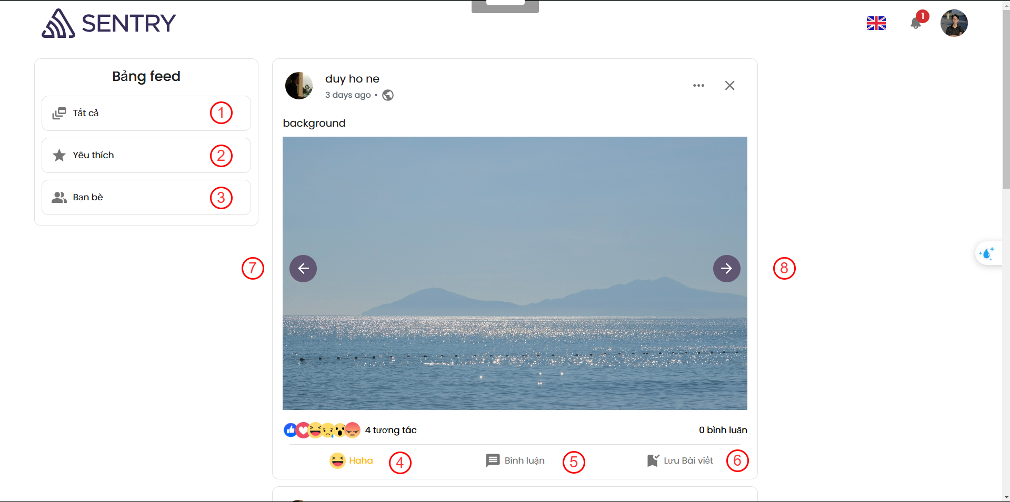

Figure 4‑26. Feed Screen

|  |  |  |  |
| --- | --- | --- | --- |
| **No.** | **Name** | **Type** | **Event** |
| 1 | Tatca | Button | The page display all of posts |
| 2 | Yeu thich | Button | The page display posts that in favorites of user |
| 3 | Ban be | Button | The page displays the posts of the user's friends. |
| 4 | Tuong tac | Selected Box | User can react the post |
| 5 | Binh luan | Button | User can comment to post |
| 6 | Luu bai viet | Button | User can save the post to Save Items |

Table 4‑26. Feed Screen

#### **4.3.2.7. Saved Items screen (SCU07)**

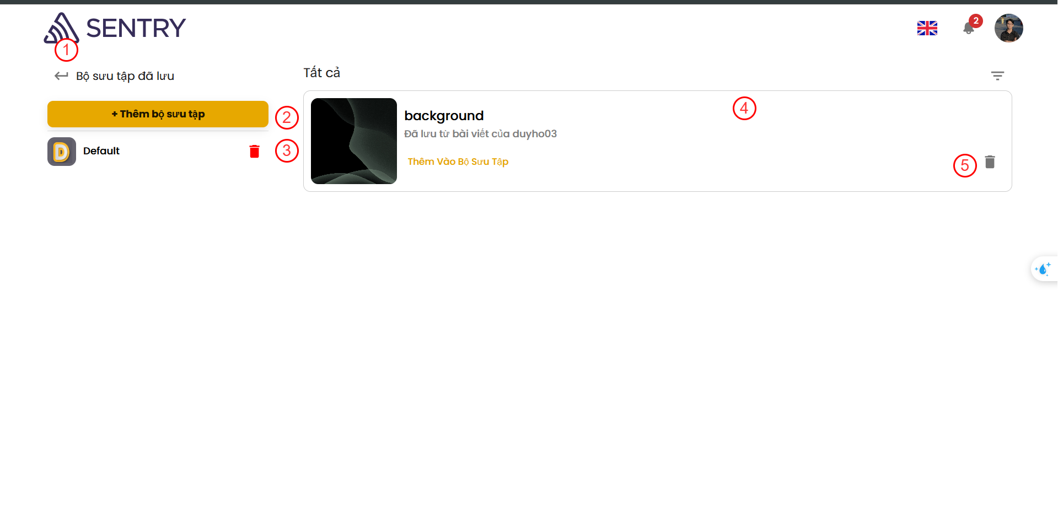

Figure 4‑27. Saved Items screen

|  |  |  |  |
| --- | --- | --- | --- |
| **No.** | **Name** | **Type** | **Event** |
| 1 | Back | Button | Back to main page |
| 2 | Them bo suu tap | Button | For user create new Collection |
| 3 | Delete | Button | Delete collection |
| 4 | Collection’s Item | TextView | Display collection’s items |
| 5 | Delete item | Button | For user can be deleted items in collection |

Table 4‑27. Saved Items screen

#### **4.3.2.8. Resource screen (SCU08)**

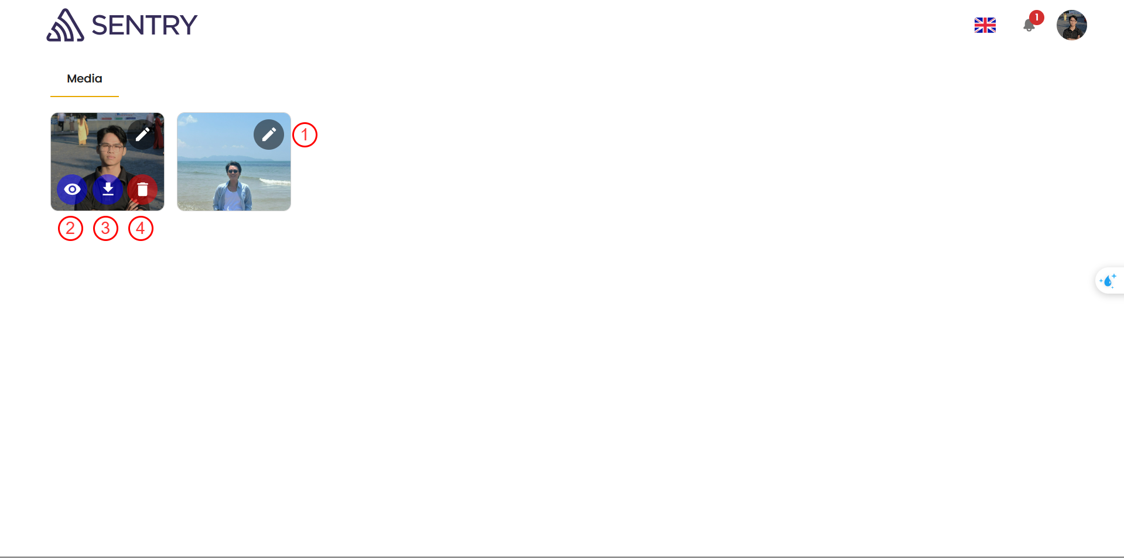

Figure 4‑28. Resource screen

|  |  |  |  |
| --- | --- | --- | --- |
| **No.** | **Name** | **Type** | **Event** |
| 1 | Edit | Button | Open edit mode. |
| 2 | View | Button | User can view image larger. |
| 3 | Download | Button | User can download image to their devices. |
| 4 | Delete | Button | User can delete media item. |

Table 4‑28. Resource screen

#### **4.3.2.9. Chat screen (SCU09)**

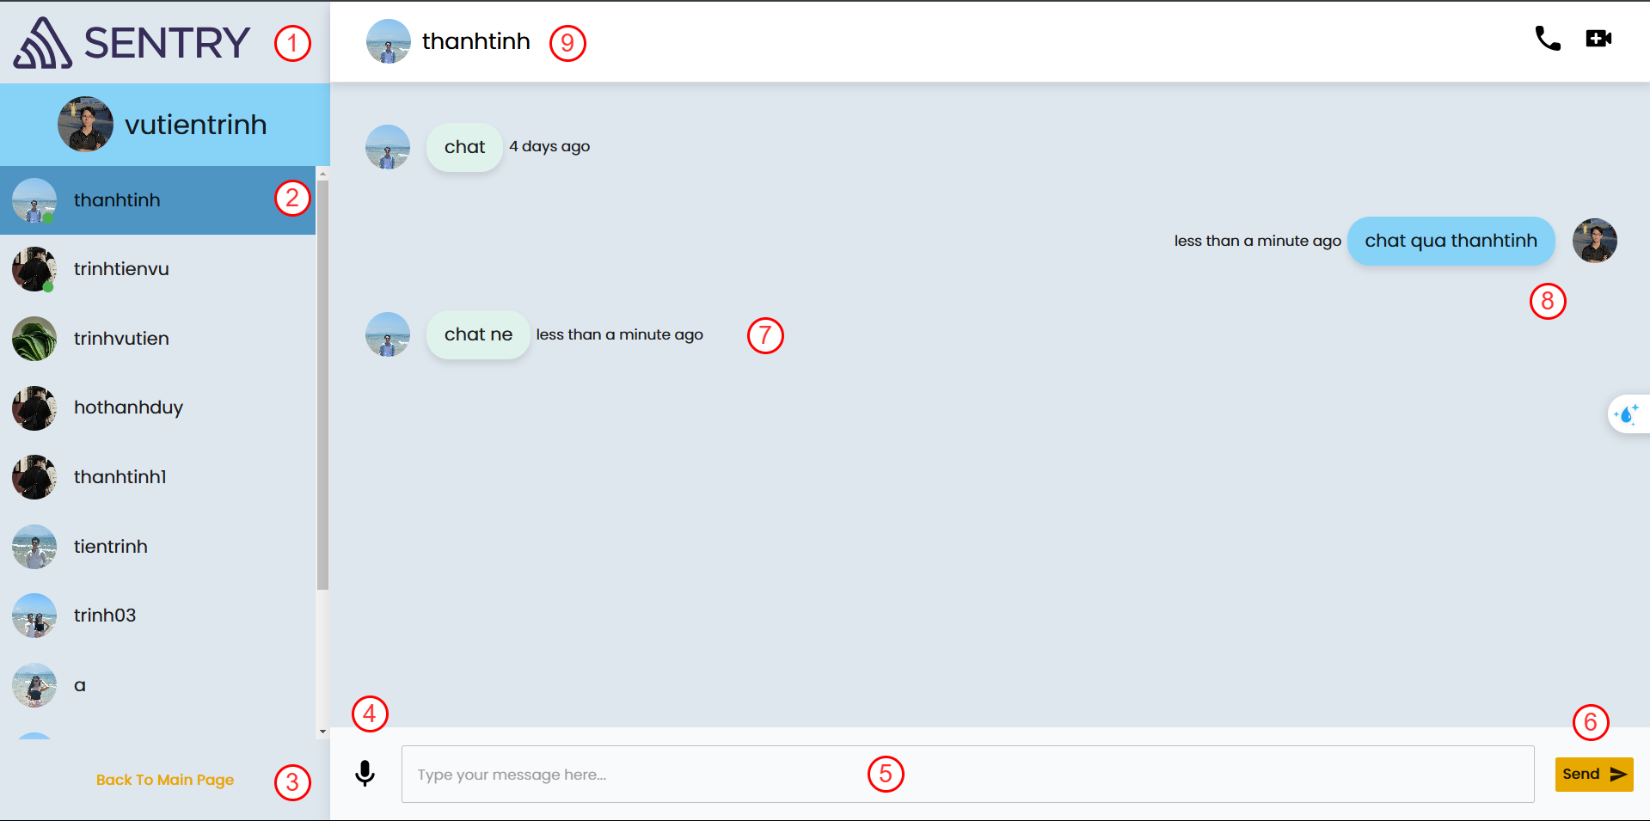

Figure 4‑29. Chatting screen

|  |  |  |  |
| --- | --- | --- | --- |
| **No.** | **Name** | **Type** | **Event** |
| 1 | Logo | Link | Back to main page |
| 2 | Other user | Button | For user can click to choose receiver message |
| 3 | Back to main page | Link | Back to main page |
| 4 | Voice recorder | Button | For user to record their voice and then it changes to text. |
| 5 | Type your message here | TextBox | For user input messages |
| 6 | Send | Button | After clicking, new message will send to receiver |
| 7 | Receiver’s message | TextView | Display Receiver’ messages |
| 8 | Sender’s messages | TextView | Display Sender’s messages |
| 9 | Receiver Information | TextView | Display name and avatar of receiver. |

Table 4‑29. Chatting screen

#### **4.3.2.10. Main friend Management Screen (SCU10)**

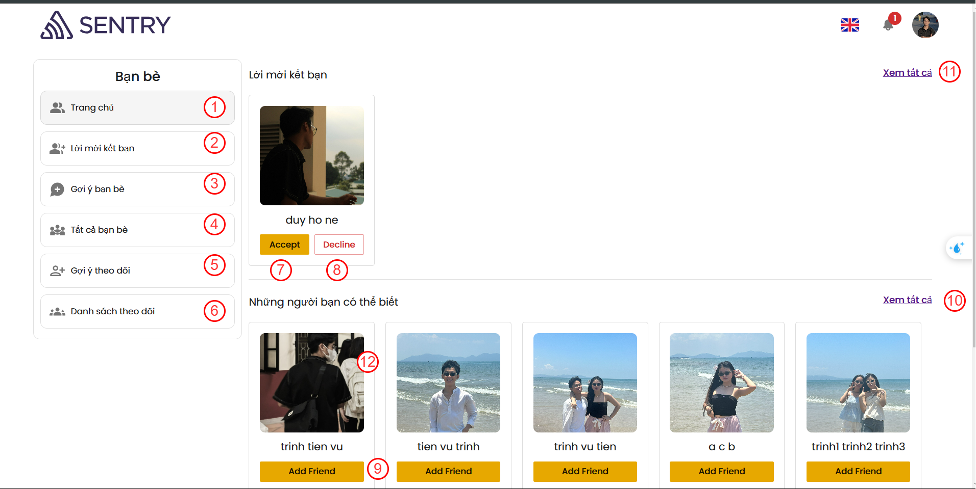

Figure 4‑30. Main friend Management Screen

|  |  |  |  |
| --- | --- | --- | --- |
| **No.** | **Name** | **Type** | **Event** |
| 1 | Trang chu | Button | After clicking, the page goes to main friend page |
| 2 | Loi moi ket ban | Button | After clicking, the page goes to new friend request screen |
| 3 | Goi y ban be | Button | After clicking, the page goes to “goi y ket ban “ screen |
| 4 | Tat ca ban be | Button | After clicking, the page goes to all friend screen |
| 5 | Goi y theo doi | Button | After clicking, the page goes to ‘goi y theo doi “ screen |
| 6 | Danh sach theo doi | Button | After clicking, the page goes to all follow screen |
| 7 | Accept | Button | For user can accept the request add new friend of other user |
| 8 | Decline | Button | For user can reject the request add new friend of other user |
| 9 | Add Friend | Button | For user send requests add new friends. |
| 10 | Xem tat ca | Link | The page goes to “goi y ban be” screen |
| 11 | Xem tat ca | Link | The page goes to new friend request screen |
| 12 | Avatar | Image | Display User avatar |

Table 4‑30. Main friend Management Screen

#### **4.3.2.11. All Friend Screen (SCU11)**

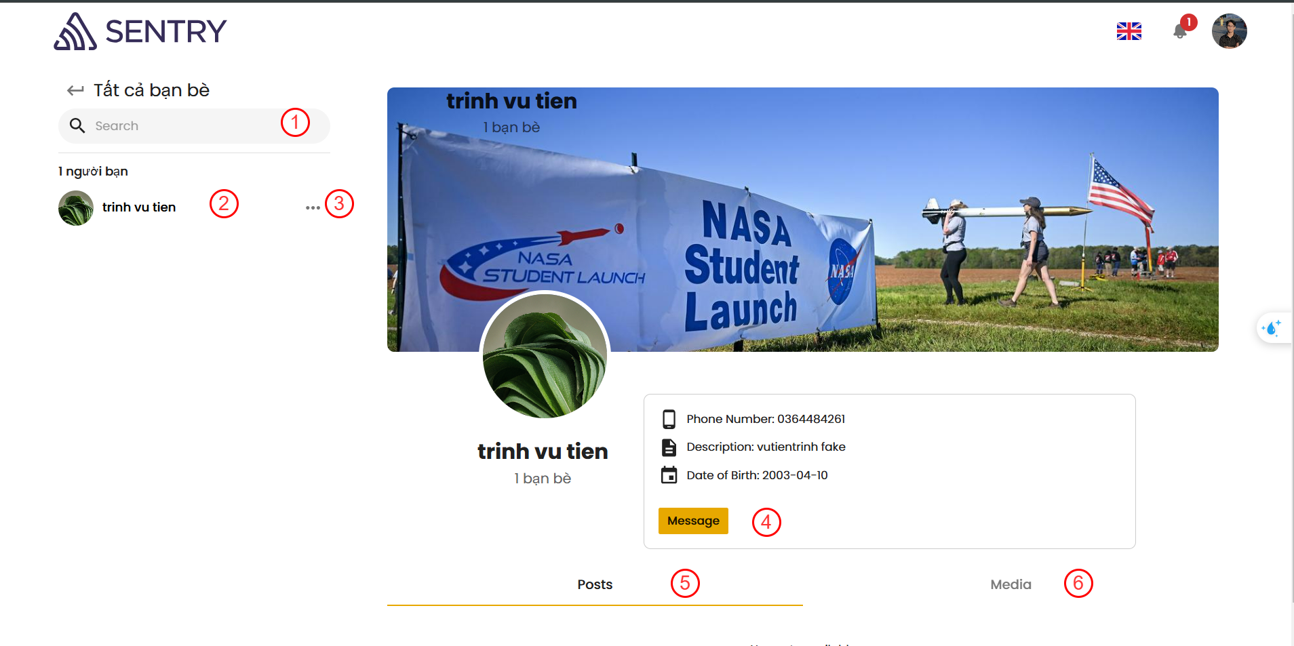

Figure 4‑31. Show All Friend Screen

|  |  |  |  |
| --- | --- | --- | --- |
| **No.** | **Name** | **Type** | **Event** |
| 1 | Search | TextBox | For user can search friend |
| 2 | Use name and avatar | TextView + Image | Display use name and avatar |
| 3 | More Option | Button | Display more option component for user can delete friend |
| 4 | Message | Button | For user can chat with friend |
| 5 | Post | Tab | Display all post of friend |
| 6 | Media | Tab | Display all media of friend |

Table 4‑31. All Friend Screen

#### **4.3.2.12. Recommend Friend screen (SCU12)**

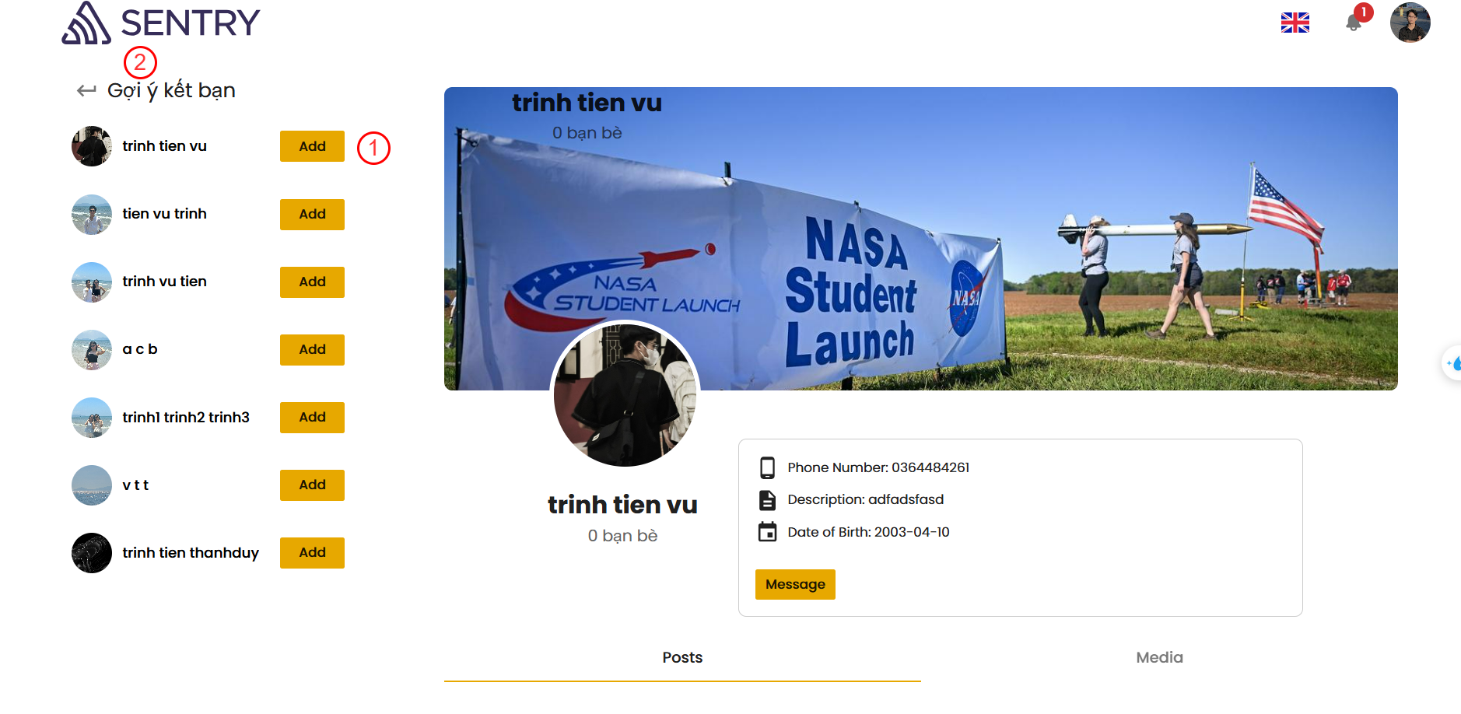

Figure 4‑32. Recommend Friend screen

|  |  |  |  |
| --- | --- | --- | --- |
| **No.** | **Name** | **Type** | **Event** |
| 1 | Add | Button | For user add new friend |
| 2 | Back | Button | Back to friend management screen |

Table 4‑32. Recommend Friend screen

#### **4.3.2.13. Follower Screen (SCU13)**

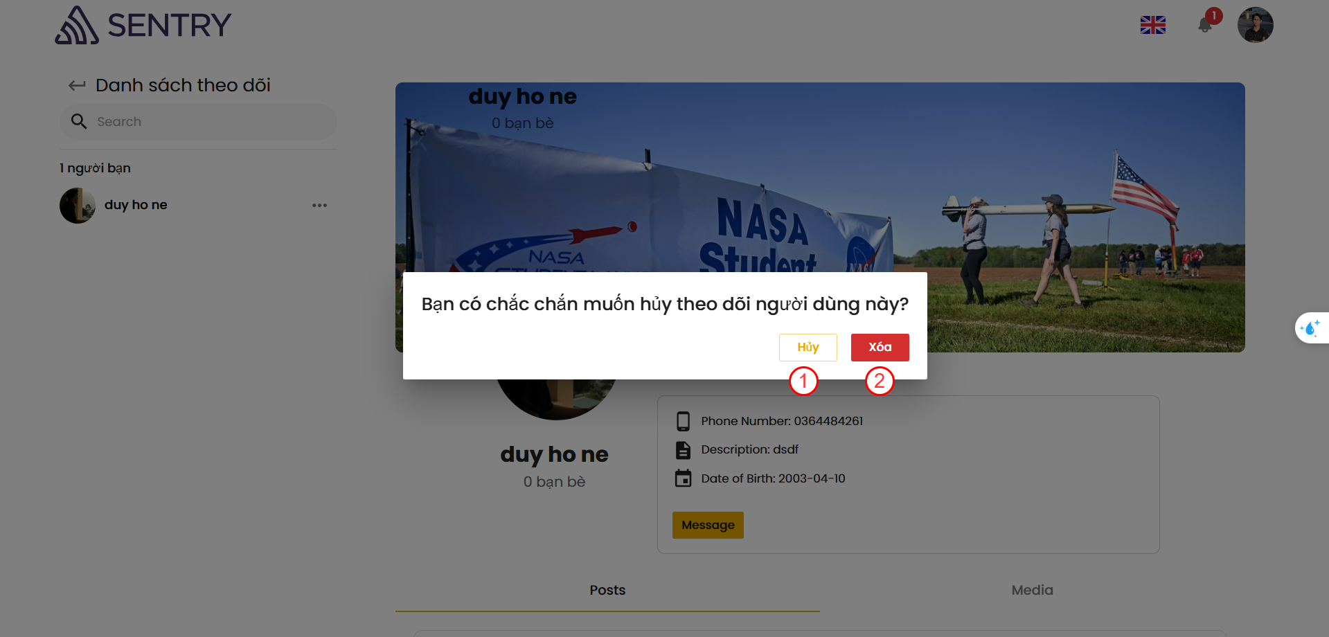

Figure 4‑33. Follow Screen

|  |  |  |  |
| --- | --- | --- | --- |
| **No.** | **Name** | **Type** | **Event** |
| 1 | Huy | Button | After clicking, user can cancel |
| 2 | Xoa | Button | After clicking, the follower is removed |

Table 4‑33. Follow Screen

# **CHAPTER 5. IMPLEMENTATION AND TESTING**

## **5.1. Implementation**

### **5.1.1. Application Implementation**

|  |  |  |
| --- | --- | --- |
| **No.** | **Application** | **Description** |
| 1 | NodeJS | - Version: v20.7.0  - Link Download:<https://nodejs.org/en/blog/release/v20.7.0> |
| 2 | Git | -Version: v2.42.0  - Link Download: <https://git-scm.com/download> |

Table 5‑1. List of application need for Social Application

#### **5.1.1.1. Back-End Implement**

*Installation Instruction*

Step 1. Clone the Repository ([SSH - Setup your github account](https://docs.github.com/en/authentication/connecting-to-github-with-ssh))

|  |
| --- |
| git clone git@github.com:SOCIAL-NETWORK-2425/social-network-backend.git |

Step 2. Set up your database

* Download PostgreSQL version 16 from the [official website](https://www.postgresql.org/download/windows/)
* Create the ***SocialMedia*** Database by psql shell:

|  |
| --- |
| CREATE DATABASE **SocialMedia**; |

Step 3. Configure the *.env* file

Set up your .env file according to the env-sample provided in the repository.

Step 4. Configure Folders

Ensure you have the necessary directories (uploadFiles, uploadImages) inside the SocialNetwork folder. If these folders are missing, navigate to the scripts directory and run the following script:

* For ubuntu run: ./init_folder.sh
* For windows run: ./init_folder.bat

Step 5. Run the Application: java -jar target/ socialnetwork-0.0.1-SNAPSHOT.war

|  |  |
| --- | --- |
| **Variables** | **Description** |
| DATABASE_URL | |  | | --- | | The JDBC connection string for connecting to the PostgreSQL database. It includes the host, port, and database name. |  |  | | --- | |  | |
| DATABASE_USERNAME | |  | | --- | | The username used to authenticate with the PostgreSQL database. |  |  | | --- | |  | |
| DATABASE_PASSWORD | |  | | --- | | The password used to authenticate with the PostgreSQL database. |  |  | | --- | |  | |
| PORT | |  | | --- | | The port on which the application server is running. |  |  | | --- | |  | |
| PUBLIC_FOLDER | |  | | --- | | The directory path for storing public assets like uploaded files or shared resources. |  |  | | --- | |  | |
| IMPORTED_FILES | |  | | --- | | The directory path for storing files that have been imported into the application. |  |  | | --- | |  | |
| BASE_FOLDER-UPLOAD | The base directory path for uploaded files within the application. |
| BASE_FOLDER | The directory path for storing locale-specific data files, such as translations or region-specific content. |
| BASE_FOLDER_LOCALE | The directory path for storing locale-specific data files, such as translations or region-specific content. |
| BASE_IMPORT_FILE | The base directory path for importing files; currently left undefined. |
| IMAGE_FOLDER | The directory path for storing uploaded images. |
| CLOUDINARY_CLOUD_NAME | The Cloudinary account identifier used to organize and manage assets. |
| CLOUDINARY_API_KEY | The API key used to authenticate with Cloudinary for uploading and managing assets. |
| CLOUDINARY_API_SECRET | The secret key used for securely authenticating requests to Cloudinary. |
| CLOUDINARY_URL | The URL string for connecting to the Cloudinary API using the provided credentials. |
| JWT_SECRET | The secret key used to sign and verify JSON Web Tokens (JWT) for secure authentication and authorization. |

Table 5‑2. Back-End env variables

#### **5.1.1.2. Front-End Implement**

*Installation Instruction*

Step 1. Clone the Repository ([SSH - Setup your github account](https://docs.github.com/en/authentication/connecting-to-github-with-ssh))

|  |
| --- |
| git clone git@github.com:SOCIAL-NETWORK-2425/social-network-frontend.git |

Step 2. Install Dependencies

Navigate to the project directory and install all required dependencies using yarn

|  |
| --- |
| cd social-network-frontend  yarn install |

Step 3. Configure Environment Variables

Copy the contents of env.sample to a new .env file in the root directory.

Step 4. Build the project: yarn build

Step 5. Run the application: yarn start

|  |  |
| --- | --- |
| **Variables** | **Description** |
| REACT_APP_BACKEND_URL | |  | | --- | | The URL of the backend API that the React application will interact with. Typically includes the protocol, host, and port. |  |  | | --- | |  | |
| REACT_APP_FRONTEND_URL | The base URL or route of the frontend application. Typically set to / to denote the root path. |
| REACT_APP_CLOUDINARY_URL | The Cloudinary URL used to access uploaded images or resources stored in the Cloudinary account. |

Table 5‑3. Front-End env variables

### **5.1.2. Tools**

|  |  |  |
| --- | --- | --- |
| **No.** | **Tool’s name** | **Descriptions** |
| 1 | Github | Source code management tools |
| 2 | Vscode | Text editor  - version: 1.95  - Link download: <https://code.visualstudio.com/download> |
| 3 | Microsoft Edge | Browser  - version: 97.0.1072.55 |
| 4 | Intellij IDEA | IDEA coding Back-End  - Version: 22.04  - Link download: <https://www.jetbrains.com/idea/download/?section=windows> |
| 5 | Draw.io | Draw schema (mockup & sequence diagram) |

Table 5‑4. Tool needed for Social Application

### **5.1.3. TechStack**

|  |  |  |
| --- | --- | --- |
| **No.** | **Technologies** | **Description** |
| 1 | PostgresSQL | Databse, storing all data of Social Media Application |
| 2 | ReactJS | Building User Interface for application |
| 3 | NodeJS | Environment to building Front-End |
| 4 | Restful API | Communication protocals for Clients and Servers |
| 5 | JsonWeb Token |
| 6 | Redux Saga | State management system |
| 7 | Cloudinary | Storing all Image for Social Media Application |
| 8 | Spring boot | Server side for Social Media Application |

Table 5‑5. Technologies Stask of Social Media Application

## **5.2. Testing**

To ensure the system's functionality, reliability, and user experience, we conducted a comprehensive suite of tests, including:

* **Functional Testing:** Verified that each feature, including core functionalities like login, chat, and CRUD operations, adhered to the specified requirements.
* **Boundary Value Analysis:** Assessed the system's behavior at the limits of input values and parameters, such as minimum and maximum allowable inputs and form field constraints.
* **Usabisility Testing:** Evaluated the system's user-friendliness and intuitiveness, focusing on seamless navigation, consistent layout, clear error messages, and overall user experience.
* **Performance Testing:** we test how the system behaves under different load conditions.
  + **Load Testing:** Simulated heavy user loads to assess the system's response times and scalability under stress.
  + **Response Time Testing:** Measured the system's performance in terms of page load times and database query execution speed.
  + **Database Performance Testing:** Evaluated the database's ability to handle large datasets and complex queries efficiently.

**Tool Utilization** Postman was employed as a tool for functional testing, enabling us to validate API endpoints, verify response accuracy, and compare actual outputs against expected results. This rigorous approach ensured that the backend services met the defined requirements effectively.

### **5.2.1. Test case**

|  |  |  |
| --- | --- | --- |
| **No.** | **Function** | **Description** |
| 1 | Login | User Login with account that user login with wrong username or password on the system |
| 2 | Add post to folder | Add post to folder ‘Deafault’ to retrieve after |
| 3 | Send friend request | Send request to new user (make new friend request) |

Table 5‑6. Test case to test function (Login, Add to folder, Send friend request)

### **5.2.2. Result of Test case**

#### **5.2.2.1. Result of test case Login Function**

|  |  |
| --- | --- |
| **Testcase1.1** | |
| Description | Test case Login function that user have incorrect username or password and trying to access system |
| Step to work | 1. Input Username and Password  2. Click ‘Login’ button |
| Test Data | Username = ‘duyho03’  Password = ‘12345’ |
| Expected Result | Alert notification:  ‘Username or password is incorrect. Please input again.’ |
| Actual Result | As expected, result |
| Conclusion | **Passed** |
| Test Images | Figure 5‑1. Testcase Login with fail username and password |

Table 5‑7. Test case Login with wrong username or password

#### **5.2.2.2. Result of test case Add Post to folder Function**

|  |  |
| --- | --- |
| **Testcase1.2** | |
| Description | Test case Add post to folder function that user can save post to Default folder to retrieve after |
| Step to work | 1. Input Username and Password  2. Click ‘Login’ button  4. Click button ‘Lưu bài viết’ |
| Test Data | Username = ‘duyho03’  Password = ‘123456’ |
| Expected Result | Alert notification:  ‘Post added to folder "Default"’ |
| Actual Result | As expected result |
| Conclusion | **Passed** |
| Test Images | Figure 5‑2. Testcase Save Items successfully |

Table 5‑8. Test case add post to folder successfully

#### **5.2.2.3. Result of test case Send friend request**

|  |  |
| --- | --- |
| **Testcase1.3** | |
| Description | Test case Send friend request function that user can send friend request to other user |
| Step to work | 1. Input Username and Password  2. Click ‘Login’ button  3. Redirect to friend page and access to ‘Gợi ý kết bạn’  4. Click ‘add friend’ button in any friend’s item |
| Test Data | Username = ‘duyho03’  Password = ‘123456’ |
| Expected Result | Alert notification:  ‘Friend request created’ |
| Actual Result | As expected result |
| Conclusion | **Passed** |
| Test Images | Figure 5‑3. Testcase Send Friend Request Successfully |

Table 5‑9. Test case Send friend request to other user

# **CHAPTER 6. CONCLUSION**

## **6.1. Achievements**

After the process of research and development of the topic “BUILDING A SOCIAL NETWORK  SYSTEM”. Our team has achieved following results:

### **6.1.1. Knowledge**

* Our team has gained an in-depth understanding of ReactJS, focusing on its application in creating dynamic and user-friendly interfaces for a social networking platform.
* We have mastered the use of Material-UI, enabling the development of responsive and visually appealing designs to enhance the user experience.
* On the backend, we have acquired significant expertise in the Spring Boot framework, which facilitated the creation of a robust and scalable server-side architecture.
* Our knowledge of PostgreSQL has expanded, particularly in terms of efficient data storage and retrieval, ensuring the integrity and security of the application’s data.
* The team has prioritized performance optimization, ensuring the system responds quickly and operates reliably under various conditions.

### **6.1.2. Skills**

* The project has greatly enhanced the team’s proficiency in full-stack development, particularly in combining ReactJS, Material-UI, Spring Boot, and PostgreSQL technologies.
* Members have developed problem-solving skills, effectively addressing challenges related to database management, backend logic, and frontend responsiveness.
* The collaborative nature of the project has fostered strong teamwork, communication, and project management skills, ensuring smooth and efficient progress.
* The team has also gained expertise in integrating and optimizing core social network features, such as user authentication, messaging, and media uploads.

### **6.1.3. Product**

* The social networking system provides a seamless user experience with its modern, allowing users to navigate the platform effortlessly.
* The backend architecture is designed for scalability and maintainability, enabling smooth operations and facilitating future upgrades or expansions
* Secure login and registration functionalities enhance trust and protect user data, fostering a reliable environment for social interactions.

## **6.2. Pros and Cons**

### **6.2.1. Pros**

* The login and registration systems incorporate advanced encryption protocols, ensuring user data and credentials remain safe.
* The platform includes real-time chatting capabilities, allowing users to communicate instantly, enhancing engagement and fostering dynamic social interactions.
* Users receive instant updates for activities such as friend requests, or post interactions, ensuring they stay informed and engaged.
* The website's dynamic content delivery and intuitive navigation collectively enhance user engagement, providing a more interactive and enjoyable browsing experience.
* The application provides robust administrative tools for managing user accounts, moderating content, and ensuring a safe and organized community environment.

### **6.2.2. Cons**

* Under extremely high user loads, there may be slight latency that requires further optimization.
* Storing and retrieving large media files like high images can increase server costs and require advanced management techniques.
* The application is not fully optimized for dynamic use on mobile phones or tablets, which may hinder the user experience for a significant portion of users who prefer these devices.

## **6.3. Future work**

* Incorporate AI-based features like personalized content recommendations and intelligent chatbots for enhanced user engagement.
* Enable live streaming and improve media file compression and storage mechanisms for better performance.
* Implement multi-factor authentication (MFA) and regular security audits to maintain data integrity.
* Add a video calling feature to enable users to communicate face-to-face, enhancing personal connections and interactions.
* Introduce group features, allowing users to create, join, and manage interest-based groups, fostering community engagement.
* Expand the platform to include e-commerce capabilities, enabling users to buy and sell products directly on the platform, such as offering a marketplace for small businesses.

# **REFERENCES**

[1] Gamma, E., Helm, R., Johnson, R. and Vlissides, J., 1994. *Design patterns*. 1st ed.

[2] Bruegge, B., & Dutoit, A. H. (2010). *Object-oriented software engineering: Using UML, patterns, and Java*. Prentice Hall.

[3] ReactJS Homepage, “*React A JavaScript library for building user interfaces”* 04/01/2016. <https://reactjs.org/>

[4] NodeJS Learn, “*Introduction to Node.js”* 16/11/2024. <https://nodejs.dev/learn>

[5] IBM Cloud Learn Hub, “*REST APIs*” 06/4/2021.

<https://www.ibm.com/cloud/learn/rest-apis>

[6] Redux Official Tutorials, *“Redux Essentials, Part 1: Redux Overview and Concepts”* 7/7/2021. <https://redux.js.org/tutorials/essentials/part-1-overview-concepts#what-is-redux>

[7] Redux Toolkit Guide, “*Redux toolkit - Usage Guide*” 21/11/2024.

<https://redux-toolkit.js.org/usage/usage-guide>

[8] Spring boot documentation, “*Documentation Spring Framework*” 26/11/2024. <https://docs.spring.io/spring-boot/index.html>

[9] Draw.io Documentation, “*Tutorial full course Draw.io proffesional*” 26/11/2024. <https://www.drawio.com/doc/>

[10] User Guide to draw.io. Introduction | by Hasali Edirisinghe, “*Guild to draw.io*” 26/11/2024.

<https://medium.com/@hasaliedirisinghe/user-guide-to-draw-io-6a1a4d7b5d33>